

赛区评阅编号： 全国评阅编号：

(由赛区填写） （全国组委会填写）

**2021年高教社杯全国大学生数学建模竞赛**

**编 号 专 用 页**

赛区评阅记录（可供赛区评阅时使用）：

|  |  |  |  |  |  |  |
| --- | --- | --- | --- | --- | --- | --- |
| 评  阅  人 |  |  |  |  |  |  |
| 备  注 |  |  |  |  |  |  |

送全国评阅统一编号:

（赛区组委会填写）

**（请勿改动此页内容和格式。此编号专用页仅供赛区和全国评阅使用，参赛队打印后装订到纸质论文的第二页上。注意电子版论文中不得出现此页。）**

1. 摘要

本文针对数学建模比赛中的多阶段打分问题进行研究

针对问题一，我们将评委重复的问题转为了图论中三角形共边问题，通过程序计算出了当评委取不同数量时，满足题设条件的论文组数。对于问题一中的规划问题，我们采用贪心算法，设计了相对合理的分组方案

针对问题二，为了得到合理的打分结果，我们先检验原数据，去除异常值，再使用Z-score规约调整各个评委的打分，使得他们的打分能用一个统一的标准去评判。经检验，我们的调分方法效果良好。

针对问题三，由于数据集存在空缺，直接采用Z-score规约无法很好的评估分数，因此我们设计了掩盖矩阵，通过该矩阵和领域预测算法来扩充数据，再进行Z-score规约，成功针对各个打分步骤进行了合理的调分。

针对问题四，综合先前解题经验，我们认定题目的步骤三和四为合理，对步骤一和二进行了合理性检验。同时我们针对总体工作量进行了评估。最后，我们提出了一种可能的改进方案。

关键词： 贪心算法 Z-score规约 领域预测 多阶段决策模型 圆桌模型

1. 问题重现

某学校举办数学建模竞赛，共有200个队比赛。组委会组织了10名评委对竞赛的论文进行评审，拟评出一等奖10%，二等奖15%，三等奖25%。

评审的步骤如下：

一、初审

将200个队的论文随机的分为20个组。

步骤（1）

打分：每个组的10篇论文由3位评委评审，分别用百分制给出评分。

排序：每个组的10篇论文根据3位评委的给分进行平均，淘汰排名靠后的40%，即4篇文章。

步骤（2）

打分：未淘汰的120篇论文，再由没有评审过的2位评委进行评审（评审时依然按原来的组进行，每组6篇），给出百分制得分。

排序：5个评委的平均给分进行排序，淘汰排名靠后的20篇文章，剩下的100篇论文为获奖论文。

二、获奖论文评审

100篇获奖论文中，排名31到40的论文，获二等奖；排名61到100的论文获三等奖；

步骤（3）

打分：排名1到30与排名41到60的50篇论文，再由2位评委进行打分，

排序：原排名41到60的20篇论文，7位评委给分平均，新排名41-50的获二等奖，新排名51-60的获三等奖；

原排名1到30的30篇论文，7位评委给分平均，新排名26-30名获二等奖，新排名1-15名获一等奖。

步骤（4）

7人平均分排名在16到25的论文，再由剩下的3位评委打分。最终排名16-20的获一等奖，最终排名21-25的获二等奖。

请你们解决如下问题：

问题一

若参加竞赛的一共有m个组（本问题中m=20），n个评委（本问题中n=10），每组论文均要给3位评委评审，给出论文与评委的分配方法（即每个评委分别评审哪些组的论文），使得任意不同的两个组的评委尽量不同。当m，n满足什么条件时能够保证任意两个组不出现3位评委一样的情况？当m，n满足什么条件时能够保证任意两个组不出现有2位评委一样的情况？对m=20，n=10，给出你认为最好的分配方案。

问题二

评审时会出现有的评委打分偏紧，有的评委打分偏松的情况。如果10个评委都评阅了所有的200篇论文，请你给出数学模型与算法，根据所有评委对每篇论文的打分，估计每位评委打分的偏差，对评委打分进行调整。

针对附录一中的数据，对评委的分数进行调整，然后根据平均分进行排序，给出获奖结果。

问题三

根据实际的评审步骤，评委不可能评阅所有的论文。在评委只评阅了部分论文后，就要对评委的分数进行调整，给出此时调整评委评分的数学模型与算法，注意，在评审的四个打分步骤之后都要利用你的算法调整评委的打分，然后对论文进行排序。

利用附录一的部分数据，计算出获奖结果。其中，评审步骤（1）,（2）的分组方案见附录二，步骤（3）中论文采取随机的方法分配给评委。

提示：由于问题三只能利用附录一中的部分数据，因此计算的评委打分的偏差以及最终的结果与问题二不一致是很正常的。

问题四

对现行的评审步骤，在评审的公正性，评委的工作量安排是否合理？给出数学模型对现行的评审步骤进行评价。根据你的评价标准，改进现行的评审步骤。

1. 问题一的分析与解决

3.1保证任意两组不出现3位相同评委的m、n取值

首先考虑组m的下限，在不考虑评委溢出的情况下，m的下限只需要大于0就满足条件，若考虑评委过多组过少的问题，那么由于每三个评委打一个组的评分，只需要m>=n/3时，评委不会溢出。

接下来考虑上限，可以将题目转变为从评委中任意选出三个不重复的排列组合，即，这就是m的上限，故最终结果为：

3.2保证任意两组不出现2位相同评委的m、n取值

首先考虑m的下限，此处同上.

接下来考虑上限，我们用图论的方法解决该问题，首先我们的总体思路为尝试将该问题转化为将评委看作点，在此基础上根据条件形成无向图问题。

随后将问题转化，首先每一组由三个评委打分，相当于从所有点之中随机选择三个点两两互连形成一个三角形的回路，接着讨论任意两个组不出现有2位评委一样的条件，因为任意两个点形成一条边，故该条件可以转变为任意两个三角形回路不共用边，所以该问题可以转变为：在一个平面上存在n个没有三点共线的点，能构造多少个没有公共边的三角形。

我们以此思路设计方案：

1. 将所有点n两两互连形成完全图
2. 以（vi，vj）代表点i，j互连形成的一条边，（vi，vj）= 0 时代表此边没有被使用，（vi，vj）= 1时代表此边被使用，而且因为是无向图，所以还有（vi，vj）=（vj，vi），所以为了方便，我们设定i < j避免为（vj，vi）赋值(i=j时不会形成边故而也不考虑)。综合为以下方程组：
3. 初始化所有(vi,vj)的值为0，令M为最终结果，初始化为0
4. 随机选取三个点v_1,v_2,v_3，若(v_1,v_2)=(v_2,v_3)=(v_1,v_3)= 0，将(v_1,v_2)，(v_2,v_3)，(v_1,v_3)置为1，并且M = M + 1。

重复4步骤遍历所有点，最终得到的M就是在评委数为n的情况下组数的上限。

用顺序选取替代随机选取，将该过程转换为代码，获得结果，然而在我们选取其中一些样本进行手工验算时，发现在n=10时，m的上限为13，而程序获得的值是10，这是点的选取问题，即顺序选取只能得到一个接近于且必然小于等于最小上界的值，而在对小样本进行归类时，我们发现对于每一个值n，M取最大时每一个点的使用次数趋于一致性（即每一个评委都尽可能评同样数量的小组），故而用五种方式优化选点：

三重循环顺序取点，即令i，j，k，2 ≤ i < n, 1 ≤ j < i，0 ≤ K < j做三重循环,每一次取点v_i,v_j,v_k

令v_first，i， 0 ≤ v_first < n 顺序递增，v_first < i < n-1， i从下限递增，此时取点v_(v_first),v_i,v_(i+1)，此步骤之后在做一次三重循环顺序取点

令v_first，i， 0 ≤ v_first < n 逆序递减，后同2

令v_first，i， 0 ≤ v_first < n 顺序递增 ，v_first < i < n-1，i为奇数时从下限递增，此时取点v_(v_first),v_i,v_(i+1)，i为偶数时从上限递减，此时取点v_(v_first),v_i,v_(i-1)，此步骤之后在做一次三重循环顺序取点

令v_first，i， 0 ≤ v_first < n 逆序递减，后同4

除了三重循环顺序取点，后四种考虑的因素是

v_first是顺序还是逆序

i 是否考虑奇偶，根据奇偶选择顺序还是逆序

经过测试，i单纯考虑顺序还是逆序这个因素对结果无影响故不考虑。

由于该代码用到三重循环，故时间复杂度为O（），在n巨大时解题时间成本会变得巨大，而我校共有本科生13350人，由代码可知M（104）=1595此时可以满足所有本科生参加数学建模，故我们只列举n<=104的情况。

根据代码，我们可以得到以下图表

|  |  |  |  |  |  |  |  |  |  |  |
| --- | --- | --- | --- | --- | --- | --- | --- | --- | --- | --- |
| n | 5 | 6 | 7 | 8 | 9 | 10 | 11 | 12 | 13 | 14 |
| M(n) | 2 | 4 | 7 | 8 | 10 | 13 | 17 | 19 | 23 | 28 |
| n | 15 | 16 | 17 | 18 | 19 | 20 | 21 | 22 | 23 | 24 |
| M(n) | 35 | 35 | 40 | 43 | 49 | 54 | 60 | 67 | 75 | 81 |
| n | 25 | 26 | 27 | 28 | 29 | 30 | 31 | 32 | 33 | 34 |
| M(n) | 89 | 96 | 104 | 113 | 126 | 140 | 155 | 155 | 158 | 165 |
| n | 35 | 36 | 37 | 38 | 39 | 40 | 41 | 42 | 43 | 44 |
| M(n) | 175 | 182 | 192 | 200 | 213 | 223 | 235 | 247 | 261 | 274 |
| n | 45 | 46 | 47 | 48 | 49 | 50 | 51 | 52 | 53 | 54 |
| M(n) | 289 | 303 | 319 | 333 | 349 | 364 | 380 | 394 | 408 | 423 |
| n | 55 | 56 | 57 | 58 | 59 | 60 | 61 | 62 | 63 | 64 |
| M(n) | 439 | 455 | 480 | 506 | 533 | 561 | 590 | 620 | 651 | 651 |
| n | 65 | 66 | 67 | 68 | 69 | 70 | 71 | 72 | 73 | 74 |
| M(n) | 652 | 654 | 662 | 678 | 696 | 713 | 731 | 748 | 766 | 783 |
| n | 75 | 76 | 77 | 78 | 79 | 80 | 81 | 82 | 83 | 84 |
| M(n) | 803 | 820 | 840 | 862 | 886 | 909 | 933 | 957 | 983 | 1008 |
| n | 85 | 86 | 87 | 88 | 89 | 90 | 91 | 92 | 93 | 94 |
| M(n) | 1035 | 1061 | 1089 | 1115 | 1143 | 1171 | 1200 | 1228 | 1257 | 1287 |
| n | 95 | 96 | 97 | 98 | 99 | 100 | 101 | 102 | 103 | 104 |
| M(n) | 1319 | 1348 | 1379 | 1410 | 1443 | 1474 | 1504 | 1534 | 1566 | 1595 |

故而m的最终取值为：

3.3 m=20，n=10情况下最佳分配方案

定义一：设代表第i组的评委编号（0<=i<20）

定义二：设代表第i组和第j组中相同评委编号的个数，为避免重复运算，令i>j

定义三：设Q为相似相似度，则需要得到Q最小的方案

在定义一，二下，因为题目说使得任意不同的两个组的评委尽量不同，那么我们认为任意两组有一位评委相同和任意两组有两位评委相同的相似程度不是线性关系的，即 。我们选取作为判断标准，

我们需要得到Q = 最小的方案，

这里我们采取贪心算法，即每一步都求局部最优解以求获得最终最优解，现在我们有两种初始化方式：  
1.什么也不设置

2.由上题可得当n=10时，M(n)=13，我们先设置13组评委两两不相同的组，之后再采取贪心算法。

在初始化方式1下，我们可以获得如下结果：

|  |  |  |  |
| --- | --- | --- | --- |
| 组编号 | 评委1编号 | 评委2编号 | 评委3编号 |
| 0 | 0 | 1 | 2 |
| 1 | 3 | 4 | 5 |
| 2 | 6 | 7 | 8 |
| 3 | 0 | 3 | 9 |
| 4 | 1 | 4 | 6 |
| 5 | 2 | 5 | 7 |
| 6 | 1 | 8 | 9 |
| 7 | 2 | 3 | 6 |
| 8 | 0 | 4 | 7 |
| 9 | 0 | 5 | 8 |
| 10 | 2 | 4 | 9 |
| 11 | 1 | 3 | 7 |
| 12 | 5 | 6 | 9 |
| 13 | 2 | 3 | 8 |
| 14 | 0 | 1 | 5 |
| 15 | 4 | 6 | 9 |
| 16 | 0 | 7 | 9 |
| 17 | 0 | 2 | 6 |
| 18 | 1 | 3 | 4 |
| 19 | 5 | 7 | 8 |

（表一）

最终相似度Q=181

在初始化方式2下，我们可以得到如下结果

|  |  |  |  |
| --- | --- | --- | --- |
| 组编号 | 评委1编号 | 评委2编号 | 评委3编号 |
| 0 | 0 | 8 | 9 |
| 1 | 0 | 6 | 7 |
| 2 | 0 | 4 | 5 |
| 3 | 0 | 2 | 3 |
| 4 | 1 | 3 | 4 |
| 5 | 1 | 5 | 6 |
| 6 | 1 | 7 | 8 |
| 7 | 2 | 4 | 6 |
| 8 | 2 | 5 | 7 |
| 9 | 3 | 5 | 8 |
| 10 | 1 | 2 | 9 |
| 11 | 3 | 6 | 9 |
| 12 | 4 | 7 | 9 |
| 13 | 2 | 4 | 8 |
| 14 | 0 | 1 | 3 |
| 15 | 5 | 6 | 8 |
| 16 | 3 | 7 | 9 |
| 17 | 0 | 5 | 9 |
| 18 | 1 | 2 | 6 |
| 19 | 4 | 7 | 8 |

（表二）

最终相似度Q=180

因为180<181，我们选取方式2的初始化方法得到的最终分配结果，并且在这个结果中，每位评委都审评6组，工作分配合理，故最佳分配方案为表二。

1. 问题二的分析与解决

4.1问题分析

题目中描述为“有的评委打分偏紧，有的评委打分偏松”，也就是说每个评委的评分标准不一样，而题目中要求的最终得分是以平均分的形式呈现的，显然直接作平均是不合理的，为此我们需要针对评委，对他们的数据分别进行调整。

4.2数据总体分析

首先我们需要对于数据总体进行分析，由于分数分布大多为正态分布，因此我们需要对于数据进行显著性检验。

取显著性水平为0.05，假设数据服从正态分布，备择假设为数据不服从正态分布。我们使用K-S检验。

通过计算得知，每位评委的打分情况和总体的打分情况的p值都大于0.05，因此接受原假设，即数据呈正态分布。

|  | D值 | P值 |
| --- | --- | --- |
| 1 | 0.04160948206793014 | 0.8646668230578755 |
| 2 | 0.03750966329942118 | 0.9309464316194455 |
| 3 | 0.038148354614719326 | 0.922109539580267 |
| 4 | 0.056971052038189196 | 0.516453874001993 |
| 5 | 0.03814835461471899 | 0.9221095395802718 |
| 6 | 0.0409681982110246 | 0.8764410590933746 |
| 7 | 0.042236924912615326 | 0.8527035610217388 |
| 8 | 0.047107227612820435 | 0.7482171297952694 |
| 9 | 0.04127894872161053 | 0.8707945465230698 |
| 10 | 0.04088679513953558 | 0.8779014514982229 |

4.3异常值处理

由于对于每个评委的打分情况不确定，而异常值对于结果的影响又较为显著，所以我们需要对数据进行异常值处理。

同时，每个评委的打分标准不同，因此如果作总体的异常值检验是不合理的，所以我们对于每个评委的打分分别作异常件检验，得出结果后再对总体进行验证。

我们采用箱线图的方式来寻找异常值，结果如下：

下限 上限 异常值

1 41.0 89.0 92,40,37

2 36.5 96.5 null

3 42.0 90.0 93,39

4 30.5 90.5 null

5 29.0 77.0 80,26

6 22.0 78.0 79

7 30.5 82.5 29

8 41.875 94.875 96,95

9 25.0 81.0 23,83

10 39.0 95.0 35

为了消除异常值，我们将超过上限的值规约为上限向下取整的整数值；将低于下限的值规约为下限向上取整的整数值.

调整异常值后的箱线图如图所示：

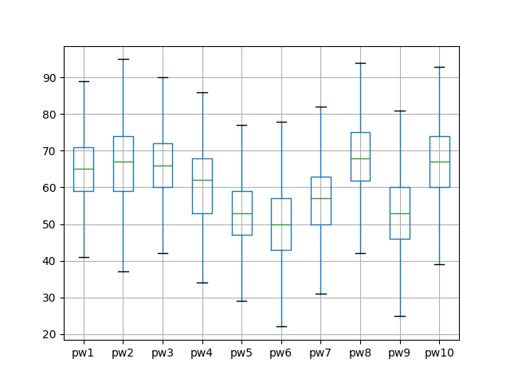

在这一节的最后，我们还对调整异常值后的数据进行了关于正态分布的检验，正态分布的检验结果如下，结果显示调分后所有评委的打分情况都符合正态分布。

|  | D值 | P值 |
| --- | --- | --- |
| 1 | 0.03986626230262025 | 0.8955226483836971 |
| 2 | 0.03750966329942118 | 0.9309464316194455 |
| 3 | 0.03721059679223626 | 0.9348820917816804 |
| 4 | 0.056971052038189196 | 0.516453874001993 |
| 5 | 0.03721059679223604 | 0.9348820917816831 |
| 6 | 0.04133371326770563 | 0.869787846748304 |
| 7 | 0.04217972833583972 | 0.8538115246386145 |
| 8 | 0.047228068946345125 | 0.7454327302335191 |
| 9 | 0.04082802726852086 | 0.8789508597256801 |
| 10 | 0.04257860367463401 | 0.8460146442996113 |
|  |  |  |

4.4标准化处理

题目的评分要求对每位评委的打分结果平均处理。

由于各个评委的打分标准不同，简单的平均处理显然不能很好地反映该组的真实得分情况；同时，每位评委有自己的评分标准，在修正了异常值后，每位评委的打分都服从正态分布，因此评委的打分有其合理性。从现实视角来说，如果简单地将十位评委的打分都按照一个统一的打分标准进行标准化处理，这无疑等价于一位评委重复十次打分，那么设置十位打分标准截然不同的评委就变得毫无意义。

因此，为了保证结果的合理性，我们对于每位评委的全部打分作Z-score标准化处理，如此便可以直接将十位评委的分求平均。在最后给定一个具有现实意义的打分时，我们选择了总体样本的均值和标准差对每组的得分进行逆Z-score处理，而这个最终结果将用于评奖.

这样的标准化处理过程既充分考虑了每位评委的打分情况，又确保了结果的可靠性

最后，为了确保最终调整结果的可靠性，我们对于调整后的数据再次进行异常值处理和正态分布检验

结果的箱线图和检验表如下：

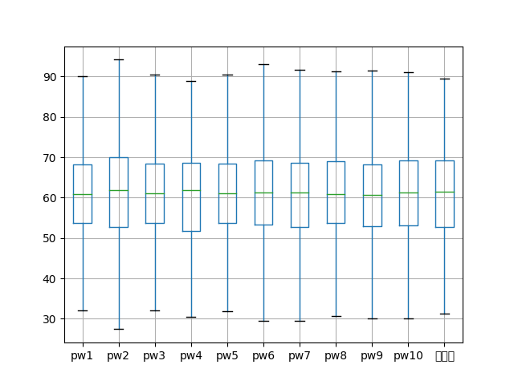

|  | D值 | P值 |
| --- | --- | --- |
| 1 | 0.039839662704691525 | 0.8959643995136999 |
| 2 | 0.037509663299421514 | 0.930946431619441 |
| 3 | 0.03722622882793025 | 0.9346795994544034 |
| 4 | 0.05697105203818942 | 0.5164538740019882 |
| 5 | 0.03721059679223582 | 0.934882091781686 |
| 6 | 0.04133371326770563 | 0.869787846748304 |
| 7 | 0.04217972833583927 | 0.8538115246386233 |
| 8 | 0.04722806894634496 | 0.7454327302335232 |
| 9 | 0.040843201085901115 | 0.8786802984875202 |
| 10 | 0.0429062368090794 | 0.8394908800191188 |
|  |  |  |

4.5最终获奖结果

1. 获一等奖的组为：   
   第69组，得分89.45204275698605   
   第151组，得分88.93927345327788   
   第134组，得分86.04991061838611   
   第15组，得分85.05440514858631   
   第183组，得分84.9266639999702   
   第153组，得分84.92441655607378   
   第5组，得分84.81167891420571   
   第61组，得分82.98460948941845   
   第165组，得分82.75447539742956   
   第83组，得分81.97797268546626   
   第173组，得分81.86782311993224   
   第148组，得分79.33017226527319   
   第98组，得分78.53440376183383   
   第10组，得分78.1396204196094   
   第163组，得分77.4208591686517   
   第147组，得分77.25033389957355   
   第139组，得分77.22431005347678   
   第89组，得分76.79239831255157   
   第161组，得分75.82557127884458   
   第101组，得分74.91813502140437
2. 获二等奖的组为：   
   第65组，得分74.84871711919979   
   第25组，得分74.14387310670755   
   第8组，得分74.1209583705734   
   第192组，得分73.74540884081318   
   第149组，得分73.67666573241688   
   第181组，得分73.54689792532858   
   第7组，得分73.43732507850831   
   第199组，得分73.25833699217354   
   第172组，得分73.18482700524268   
   第48组，得分72.75822388413002   
   第166组，得分72.2861070027786   
   第132组，得分72.09367040955381   
   第177组，得分72.07499421567768   
   第100组，得分71.88605116725782   
   第168组，得分71.7173295642154   
   第129组，得分71.41132925529902   
   第122组，得分71.40768921259418   
   第178组，得分71.1055312123787   
   第156组，得分71.09330769429057   
   第76组，得分70.98154244305127   
   第102组，得分70.82369321503347   
   第196组，得分70.7753948278049   
   第81组，得分70.57291095433524   
   第121组，得分70.1589485323026   
   第90组，得分69.94405404633913   
   第162组，得分69.91712685177188   
   第180组，得分69.64604206980034   
   第91组，得分69.49886975460124   
   第115组，得分69.45562306425163   
   第94组，得分69.22565258148249
3. 获三等奖的组为：   
   第27组，得分68.32238268817862   
   第87组，得分68.13482991396522   
   第41组，得分68.01299989992371   
   第128组，得分67.78370241971274   
   第113组，得分67.73986757496517   
   第97组，得分67.33253432330164   
   第42组，得分67.2010977879061   
   第198组，得分67.05855252806205   
   第49组，得分66.73164781571225   
   第176组，得分66.63794931448882   
   第171组，得分66.43865526906842   
   第62组，得分66.30723121843536   
   第46组，得分66.29501152138089   
   第2组，得分66.05392537824821   
   第68组，得分66.00766628506396   
   第21组，得分65.8763592928166   
   第175组，得分65.74249183001453   
   第103组，得分65.52078242708284   
   第189组，得分65.39883531234669   
   第70组，得分65.18141233899088   
   第75组，得分65.09632133703548   
   第35组，得分65.09007668954861   
   第104组，得分64.99060993610053   
   第123组，得分64.92576366087346   
   第86组，得分64.88045198928906   
   第14组，得分64.72974099851305   
   第95组，得分64.64847282504584   
   第24组，得分64.44552400524725   
   第187组，得分64.05246853480101   
   第17组，得分64.03494490039523   
   第71组，得分63.83821130410786   
   第19组，得分63.827645033804345   
   第137组，得分63.51857837670784   
   第54组，得分63.51489498883624   
   第114组，得分63.44875635481168   
   第28组，得分63.331047844461935   
   第124组，得分63.21015552466213   
   第88组，得分63.181659228071055   
   第157组，得分63.087411761355   
   第159组，得分62.8620196369332   
   第136组，得分62.75022438398626   
   第79组，得分62.71442200592664   
   第119组，得分62.69594299504693   
   第133组，得分62.526170680153314   
   第141组，得分62.47541818820234   
   第34组，得分62.32818972975366   
   第110组，得分62.23126449633846   
   第58组，得分61.64143116201667   
   第55组，得分61.46693547976238
4. 问题三的分析与解决

5.1 问题分析

对于该问题，我们采用Z-score规约进行调分。如此我们便可以使用调分后的打分直接作平均值来评估小组的论文得分情况。

由于题目中存在四个打分步骤，而每个打分步骤结束以后都要进行调分，对调分后的结果进行排名，然后选出这一步骤中的淘汰小组和获奖小组。同时，由于一旦某个小组获得了奖项或者被淘汰，那么该小组的评委打分数据就不能再次被使用。这就造成了数据集过少和数据集状态问题。而对于缺失的数据集，直接使用Z-score规约会使得结果出现很大的误差，所以我们需要填充数据集。为此我们采用了掩蔽矩阵，领域预测和Z-score规约来设计我们的调分算法。

5.2 模型部分组件构成

5.2.1 掩蔽矩阵

为了解决数据集状态问题，即每个步骤中可用的数据都是变化的，我们设计了掩蔽矩阵来描述每个步骤中可以被使用的数据。以下左图为矩阵数值的公式和部分矩阵展示。

在根据给定的分组情况获取对用的掩蔽矩阵后，由于掩蔽矩阵可以与原数据对应，我们使用掩蔽矩阵对原数据进行处理，保留本轮需要使用的数据，将不需要的数据置为NaN，最终得到的处理完毕的数据如下右图所示。

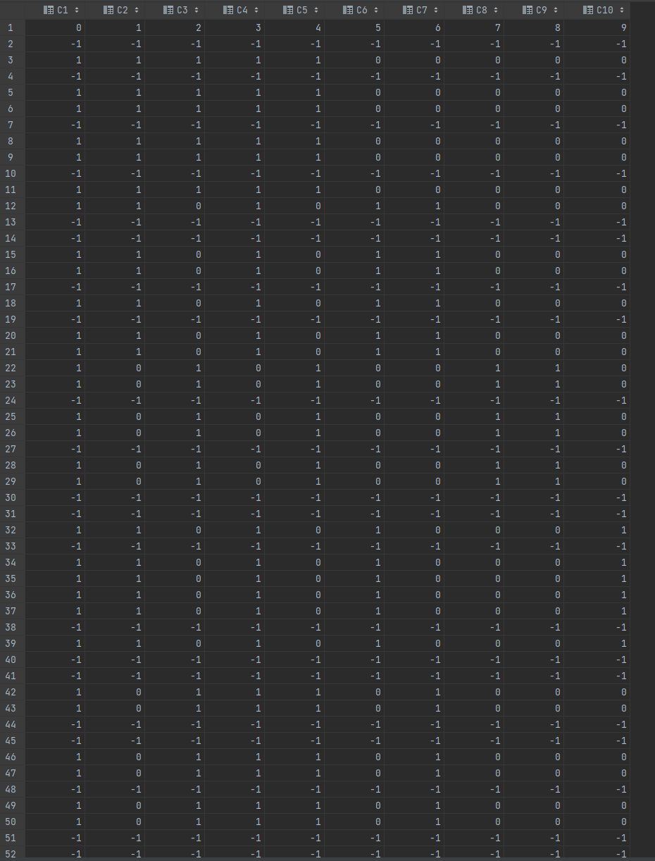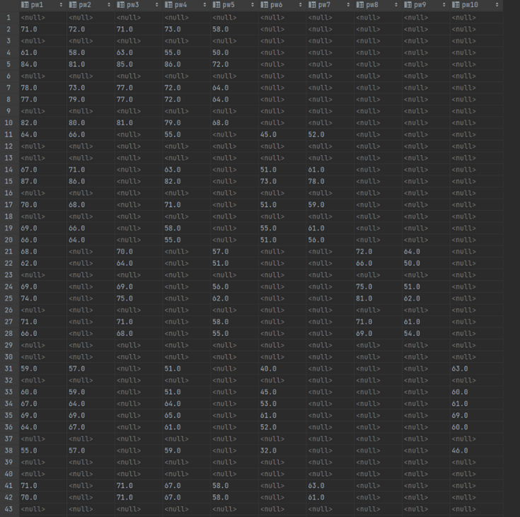

5.2.2 邻域预测

由于每个评委不可能对所有论文打分，所以出现了数据集的缺失。同时，如果每个评委对每篇论文都打分了那么这样的结果一定是最好的。为了使现有的缺失数据集达到后者的完备状态以进行更好地调分，我们采用了领域预测的方式，通过计算每个评委在每篇论文的打分上的相关性，预测该评委在其未打分的小组上的可能的打分，使得每个小组都被全部十位评委打分，从而使数据集达到如问题二的数据的完备形式。

5.2.3 Z-score规约

在获取了完备数据集的情况下，我们便可以参照问题二的解法，对于数据集作Z-score规约，从而使得每个评委的打分情况全被被规约到一个统一的标准，使直接的数值平均能反映小组得分的真实情况。

5.3 模型详细说明

5.3.1 步骤一

在步骤一中，各个评委的分组情况是给定的，因此我们需要根据分组情况，获取在这一轮中的掩蔽矩阵。在获取了掩蔽矩阵后，我们根据该掩蔽矩阵对于原始的数据作掩蔽处理，获取在步骤一中可见的数据。在获取了可见数据后，为了扩充数据集，我们对于该可见数据作领域预测，填补表中的数据空缺。

领域预测计算的相关性矩阵如下：

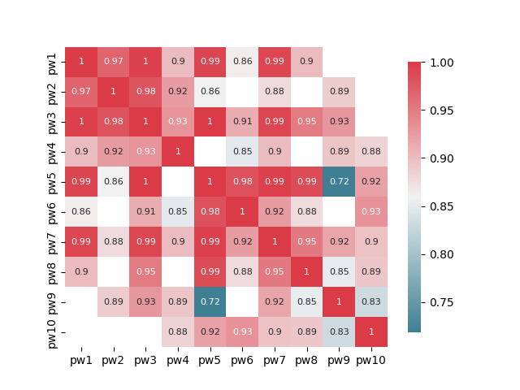在获取到填补结果后，便可以对该结果作Z-score规约，然后对于Z-score规约后的结果，我们可以直接根据掩蔽矩阵，计算该小组在步骤一中的对应的三个评委的打分的平均值，最终部分结果如下：

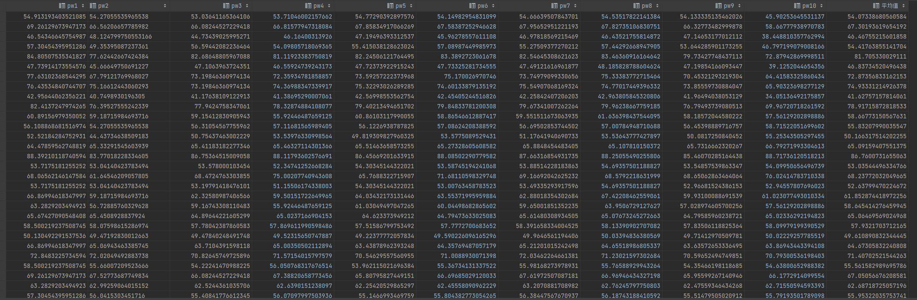

根据步骤一的排序方式，我们对每个10组大组进行排序，淘汰该大组中排名为后40%的小组，更新掩蔽矩阵，将已经被淘汰的小组对应的掩蔽矩阵中的值置为-1.

5.3.2 步骤二

在步骤二中，各个评委的分组情况是给定的，因此我们需要根据分组情况，获取在这一轮中的掩蔽矩阵，步骤二的掩蔽矩阵中的部分数据如下图：

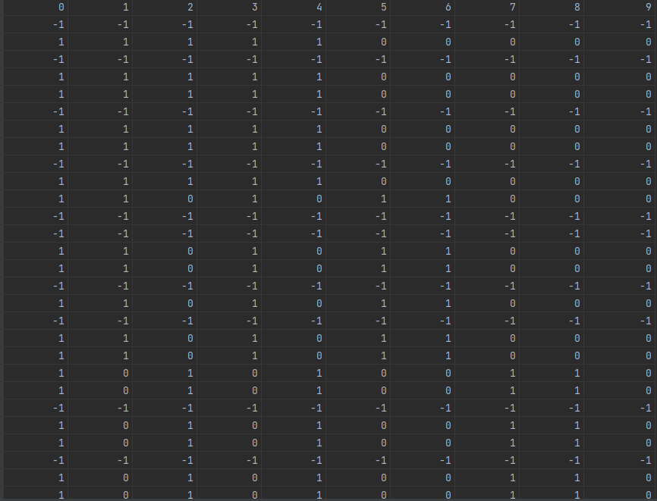

在获取了掩蔽矩阵后，我们根据该掩蔽矩阵对于原始的数据作掩蔽处理，获取在步骤二中可见的数据。步骤二的可见数据的部分数据如下：

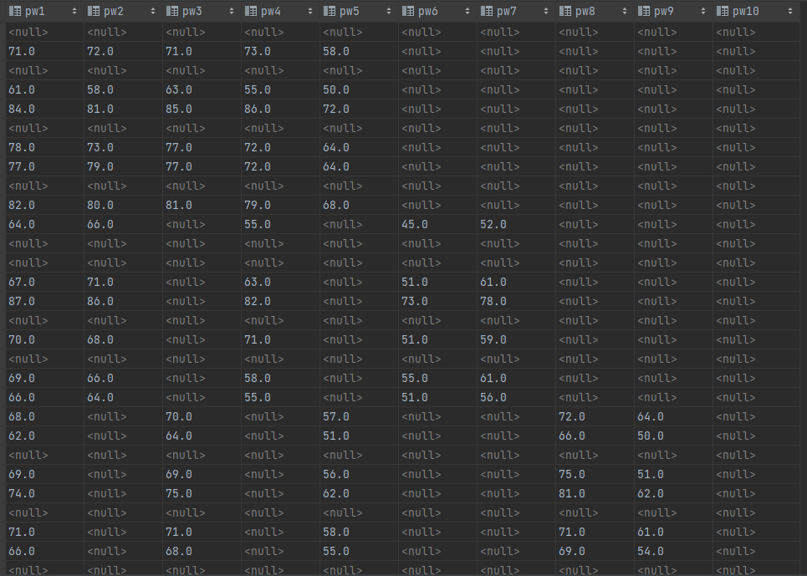

如图所示，第一组在步骤一中已被淘汰，因此在步骤二中，第一组的数据便不再可用。

在获取了可见数据后，为了扩充数据集，我们对于该可见数据作领域预测，填补表中的数据空缺。填补的部分结果如下：

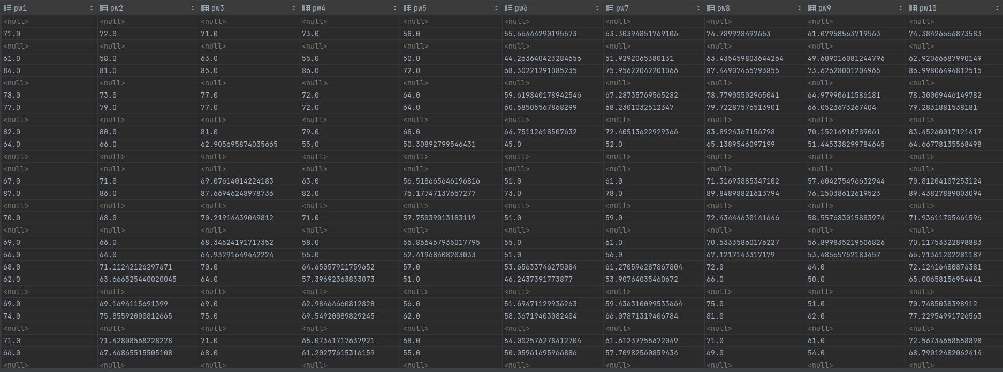

领域预测计算的相关性矩阵如下：

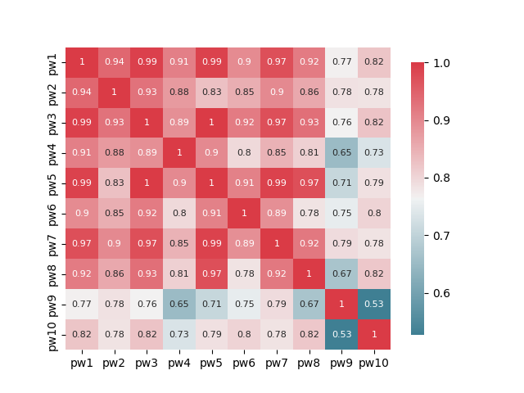

在获取到填补结果后，便可以对该结果作Z-score规约，然后对于Z-score规约后的结果，我们可以直接根据掩蔽矩阵，计算该小组在步骤二中的对应的五个评委的打分的平均值，最终部分结果如下：

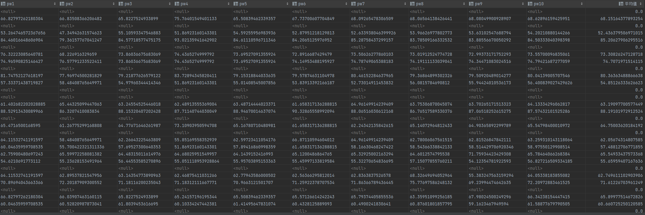

根据步骤二的排序方式，我们对每个10组大组的所有未被淘汰的论文进行排序，淘汰排名为后20名的小组，排名31到40的小组，获二等奖。排名61到100的小组，获三等奖。

5.3.3 步骤三

在步骤三中，我们需要对步骤二中排名1到30和41到60的论文，每次额外随机抽取两位评委进行评分，我们对两组论文分别随机选取评委，生成他们对应的掩蔽矩阵，如下图所示：

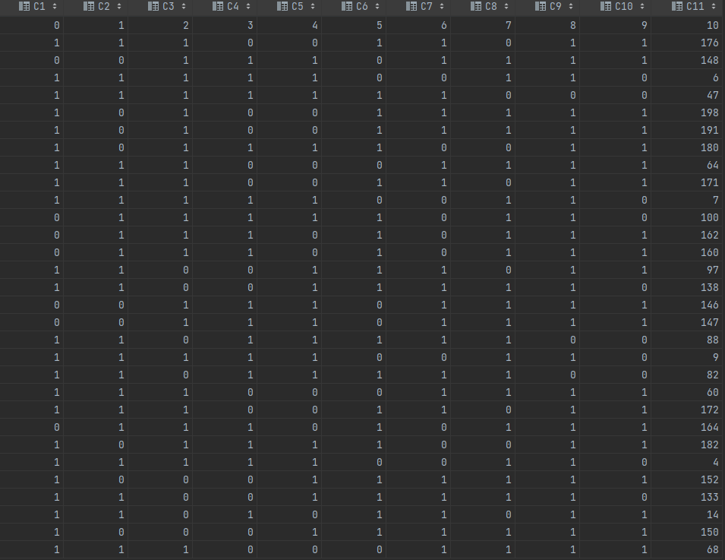

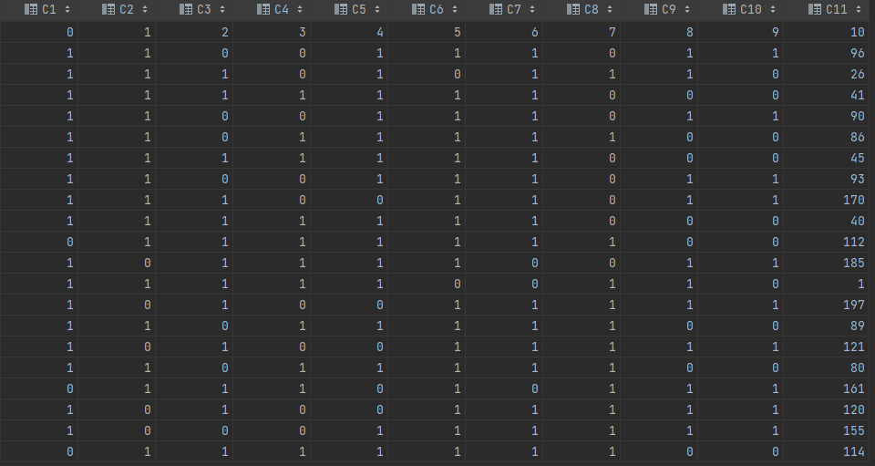

需要指出的是，由于先前的已经被淘汰的小组和已经获奖的小组的数据无法使用，于是我们缩小了掩蔽矩阵，添加了新的列来表征对应的小组号。

在获取了掩蔽矩阵后，我们根据该掩蔽矩阵对于原始的数据作掩蔽处理，获取在步骤三中可见的数据。步骤三的可见数据的部分数据如下：

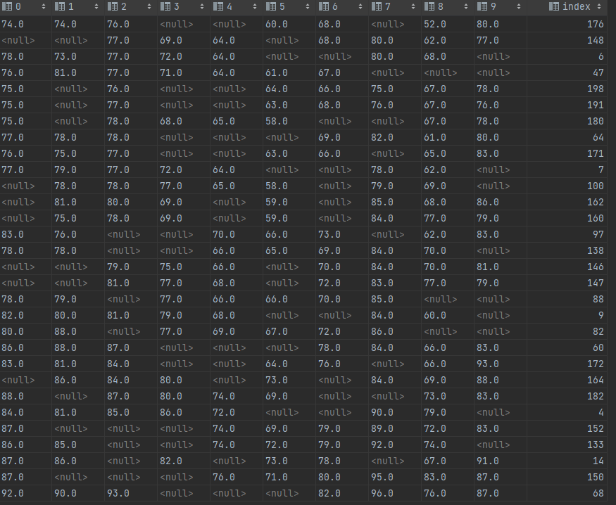

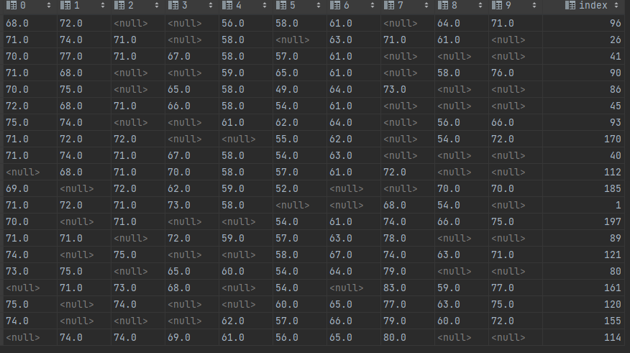

在获取了可见数据后，为了扩充数据集，我们对于该可见数据作领域预测，填补表中的数据空缺。填补的部分结果如下：

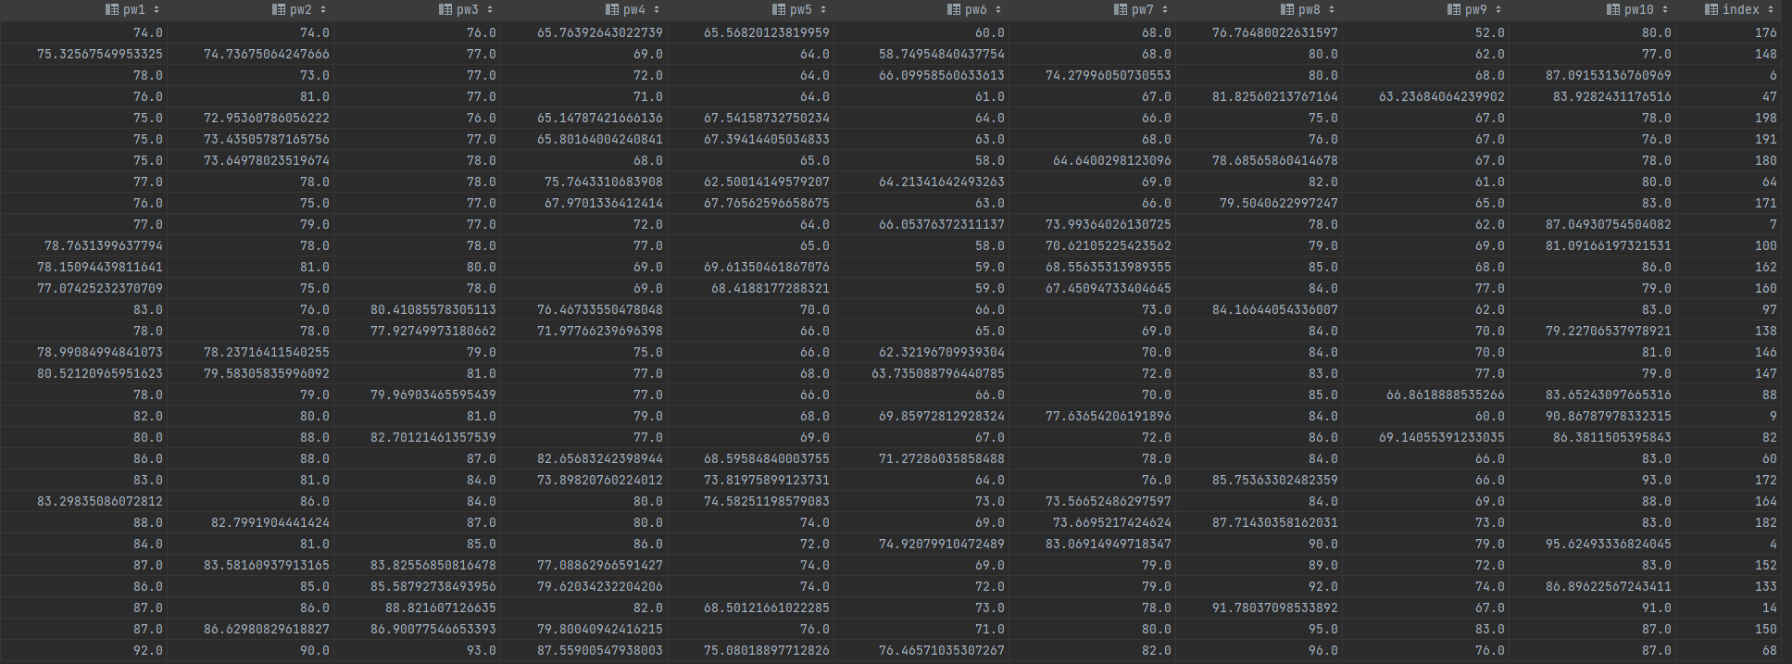

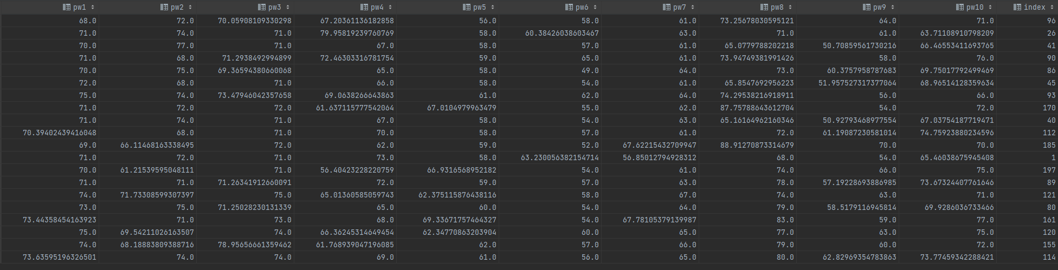

领域预测计算的相关性矩阵如下：

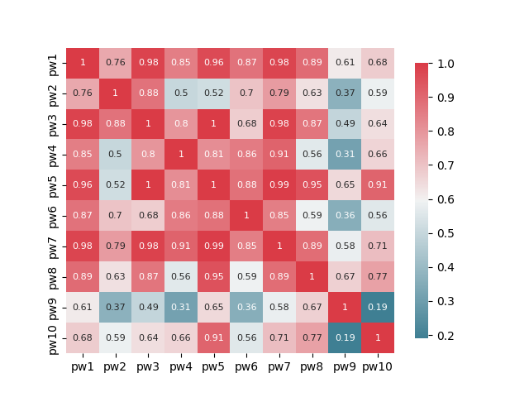

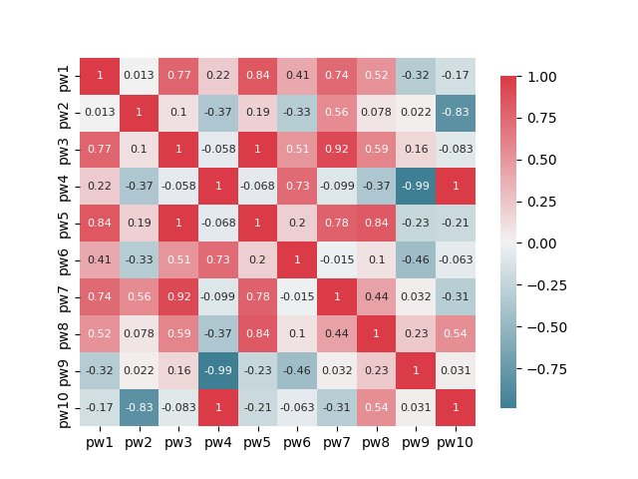

在获取到填补结果后，便可以对该结果作Z-score规约，然后对于Z-score规约后的结果，我们可以直接根据掩蔽矩阵，计算该小组在步骤三中的对应的七个评委的打分的平均值，最终部分结果如下：

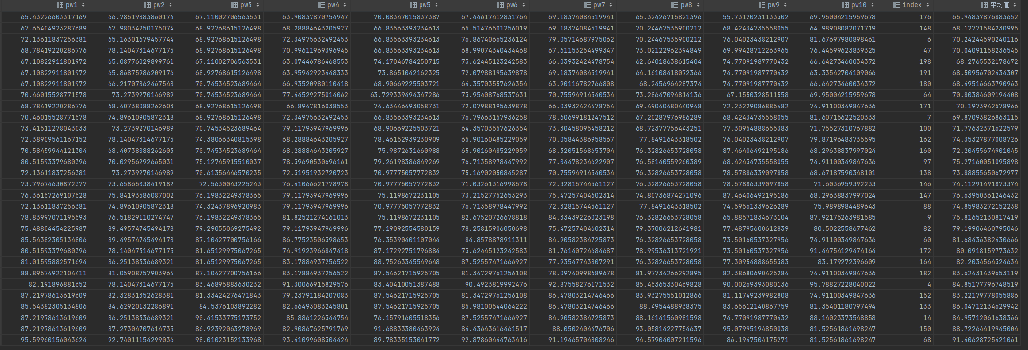

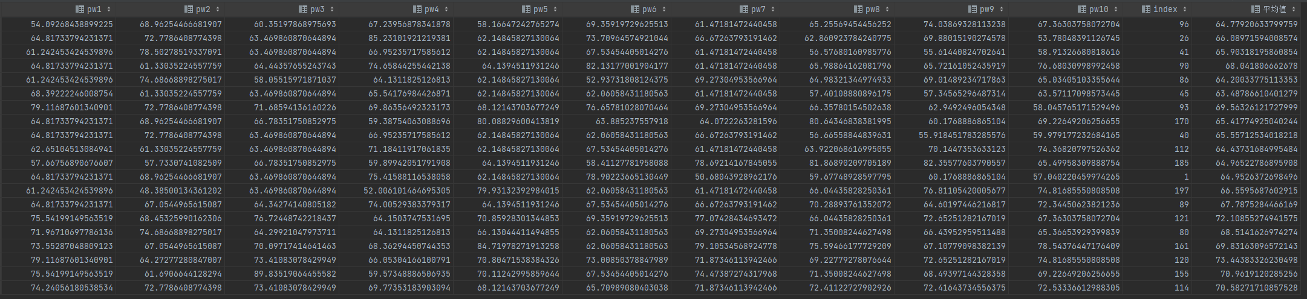

根据步骤三的排序方式，原排名41到60的20篇论文，7位评委给分平均，新排名41-50的获二等奖，新排名51-60的获三等奖；

原排名1到30的30篇论文，7位评委给分平均，新排名26-30名获二等奖，新排名1-15名获一等奖。

5.3.4 步骤四

在步骤四中，我们需要对步骤三中排名16到25的论文，让全部十位评委进行评分，我们生成对应的掩蔽矩阵，如下图所示：

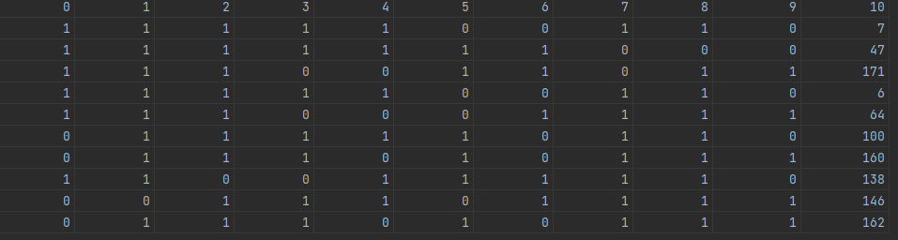

在获取了掩蔽矩阵后，我们根据该掩蔽矩阵对于原始的数据作掩蔽处理，获取在步骤四中可见的数据。步骤四的可见数据如下：

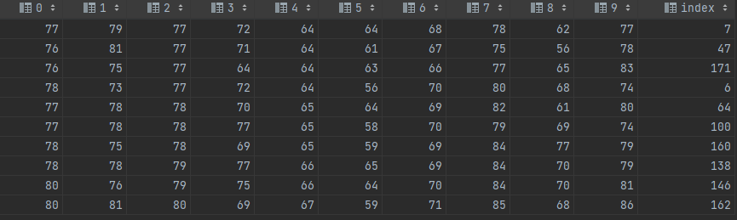

由于步骤四中全部十位评委都参与了打分，因此我们不需要使用领域预测填补数据。

在获取到填补结果后，便可以对该结果作Z-score规约，然后对于Z-score规约后的结果，我们可以直接根据掩蔽矩阵，计算该小组在步骤三中的对应的七个评委的打分的平均值，最终部分结果如下：

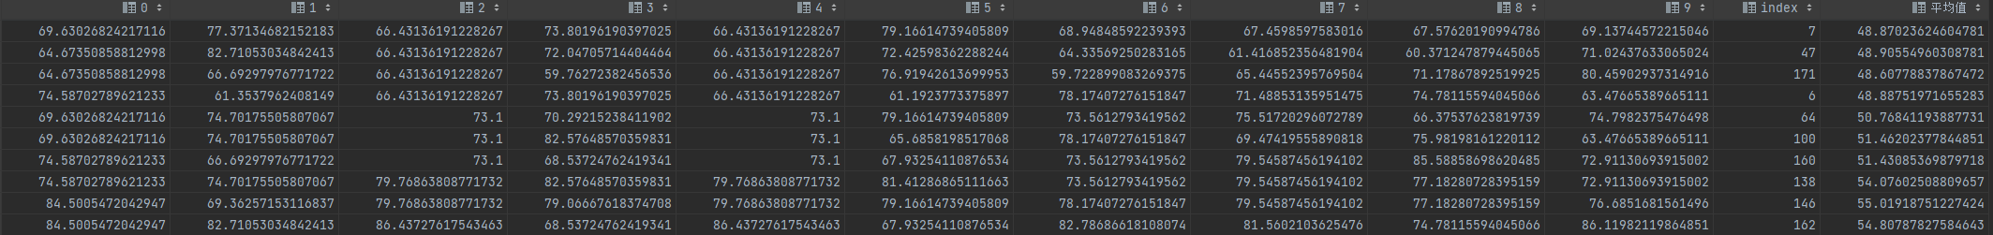

根据步骤四的排序方式，最终排名16-20的获一等奖，最终排名21-25的获二等奖。

5.4 获奖结果

第一步淘汰:   
第1大组：   
第9组：,得分：41.62757157814061   
第3组：,得分：46.46755215601858   
第6组：,得分：46.83734520496438   
第1组：,得分：54.07338680560584   
第2大组：   
第13组：,得分：50.166317514202255   
第18组：,得分：52.63799470224672   
第16组：,得分：53.03544496334766   
第12组：,得分：55.83207990035547   
第3大组：   
第23组：,得分：49.610890832344445   
第26组：,得分：55.561582989695786   
第29组：,得分：55.95322035753741   
第30组：,得分：57.14197457737627   
第4大组：   
第39组：,得分：33.67957730702623   
第37组：,得分：45.13321526030566   
第40组：,得分：49.48776975396152   
第32组：,得分：50.24582331941354   
第5大组：   
第47组：,得分：40.29612954344943   
第43组：,得分：42.285224689203794   
第44组：,得分：44.67736345794551   
第50组：,得分：48.653614568461656   
第6大组：   
第53组：,得分：46.364672417773846   
第57组：,得分：47.14357980980223   
第56组：,得分：51.82391835484545   
第51组：,得分：55.33346256730272   
第7大组：   
第67组：,得分：37.76898353529103   
第63组：,得分：39.99722560293798   
第66组：,得分：49.869159946684135   
第64组：,得分：50.87550613831246   
第8大组：   
第78组：,得分：31.398463560754838   
第80组：,得分：37.812845022042765   
第72组：,得分：52.13017322194364   
第74组：,得分：54.12969130695421   
第9大组：   
第85组：,得分：49.16192404340551   
第82组：,得分：58.454126279952   
第86组：,得分：60.79599442502964   
第84组：,得分：61.2755719247744   
第10大组：   
第92组：,得分：49.91656177138068   
第99组：,得分：55.06172563578984   
第93组：,得分：59.00600433741463   
第96组：,得分：61.44130056345612   
第11大组：   
第109组：,得分：52.80426415118512   
第108组：,得分：53.97259856423148   
第106组：,得分：57.16016236288374   
第105组：,得分：57.53695546001668   
第12大组：   
第116组：,得分：44.69576453607479   
第120组：,得分：52.2649122525901   
第117组：,得分：52.66831398135178   
第111组：,得分：55.05857075621725   
第13大组：   
第126组：,得分：40.770968172157474   
第125组：,得分：56.13166982926713   
第127组：,得分：58.5311522842757   
第130组：,得分：58.92648663635611   
第14大组：   
第131组：,得分：37.51539544146138   
第140组：,得分：53.919174032454855   
第138组：,得分：57.85516380431371   
第135组：,得分：58.60143347780309   
第15大组：   
第145组：,得分：49.427299740465145   
第146组：,得分：50.60915253572554   
第142组：,得分：51.36501083237072   
第150组：,得分：54.51095222400619   
第16大组：   
第155组：,得分：36.03082398155854   
第154组：,得分：48.88360395567121   
第158组：,得分：49.67875744907388   
第152组：,得分：52.81242375576321   
第17大组：   
第167组：,得分：34.049089147169944   
第169组：,得分：39.07565947428069   
第170组：,得分：43.35060102286068   
第164组：,得分：46.02544394807003   
第18大组：   
第179组：,得分：51.49537313019601   
第174组：,得分：52.69923058941942   
第175组：,得分：64.48418525317908   
第180组：,得分：66.08411212470793   
第19大组：   
第182组：,得分：30.614532915736746   
第184组：,得分：51.66374619582359   
第188组：,得分：53.12793938598188   
第190组：,得分：57.85231737314734   
第20大组：   
第195组：,得分：46.58969111991704   
第194组：,得分：46.96406395362399   
第200组：,得分：54.29352742955749   
第197组：,得分：54.67881400571556   
第二步淘汰:   
第38组：,得分：43.61374744112697   
第31组：,得分：48.9388142945343   
第33组：,得分：50.314913666880265   
第193组：,得分：51.88974551725745   
第4组：,得分：52.436379506971015   
第143组：,得分：52.780130209241136   
第77组：,得分：54.5519982632609   
第60组：,得分：54.74446826697863   
第11组：,得分：54.85126333626623   
第73组：,得分：55.46705543057279   
第22组：,得分：55.65959407167636   
第45组：,得分：55.93246683912294   
第191组：,得分：55.97418604632105   
第52组：,得分：56.315461938448365   
第144组：,得分：56.64885200722707   
第160组：,得分：57.19066023675593   
第20组：,得分：57.48812706771855   
第112组：,得分：57.6032730225793   
第36组：,得分：58.10635609046301   
第185组：,得分：58.27281577838613   
第二步获二等奖:   
第118组：,得分：58.43681551454781   
第59组：,得分：58.57581036283182   
第141组：,得分：58.79474274121752   
第107组：,得分：58.8251027381753   
第55组：,得分：58.90850055225599   
第133组：,得分：58.93877967501074   
第34组：,得分：59.39388076248555   
第114组：,得分：59.75620607445977   
第110组：,得分：59.85040154458056   
第58组：,得分：59.95232699304991   
第71组：,得分：60.08399822141032   
第79组：,得分：60.31727749646528   
第28组：,得分：60.660725250120585   
第137组：,得分：60.794596452037936   
第157组：,得分：60.860741399545056   
第159组：,得分：60.88088441247364   
第136组：,得分：60.91702143616068   
第187组：,得分：61.66185654285745   
第95组：,得分：61.72453855337094   
第19组：,得分：62.05674314807585   
第124组：,得分：62.62173690785424   
第123组：,得分：62.74006818467808   
第24组：,得分：62.74961110290391   
第103组：,得分：62.83057132176706   
第14组：,得分：63.19097700577449   
第104组：,得分：63.33278086941671   
第119组：,得分：63.340011894208416   
第88组：,得分：63.37173343873786   
第75组：,得分：63.56895988357068   
第176组：,得分：63.68087604799259   
第54组：,得分：64.10933810731505   
第68组：,得分：64.32443155074687   
第70组：,得分：64.44763227815702   
第62组：,得分：64.60312572938324   
第17组：,得分：64.75003620184192   
第128组：,得分：64.85158128589937   
第189组：,得分：65.21395784118504   
第21组：,得分：65.54933437573368   
第49组：,得分：65.63790126559874   
第35组：,得分：65.69244337641274   
第二步获三等奖:   
第76组：,得分：70.88876358460627   
第168组：,得分：70.94210913179819   
第100组：,得分：71.34028658163267   
第178组：,得分：71.41491927586644   
第25组：,得分：71.61226703961249   
第132组：,得分：71.74036117133691   
第129组：,得分：71.76405730756399   
第196组：,得分：71.93407546343917   
第166组：,得分：71.94227599338558   
第102组：,得分：72.45888971091973   
第三步的1-30名中，获二等奖为：   
第177组：,得分：65.94837876883652   
第149组：,得分：68.12771584230995   
第199组：,得分：68.2765532178672   
第181组：,得分：68.49516663790963   
第192组：,得分：68.50956702434307   
第三步的1-30名中，获一等奖为：   
第89组：,得分：74.85983272152238   
第98组：,得分：75.27160051095898   
第10组：,得分：75.81652130817419   
第148组：,得分：76.63950361246432   
第83组：,得分：79.19906460795046   
第173组：,得分：80.0918159773632   
第61组：,得分：81.68436382430666   
第165组：,得分：82.2034564324634   
第153组：,得分：83.22179778055886   
第183组：,得分：83.62431439653119   
第5组：,得分：84.85177796748519   
第15组：,得分：84.95712061638366   
第134组：,得分：86.04712134629942   
第151组：,得分：88.72264419945004   
第69组：,得分：91.4062872542106   
第四步中，获二等奖为：   
第172组：,得分：48.60778837867472   
第8组：,得分：48.87023624604781   
第7组：,得分：48.88751971655283   
第48组：,得分：48.90554960308781   
第65组：,得分：50.76841193887731   
第四步中，获一等奖为：   
第161组：,得分：51.43085369879718   
第101组：,得分：51.46202377844851   
第139组：,得分：54.07602508809657   
第163组：,得分：54.80787827584643   
第147组：,得分：55.01918751227424

1. 问题四的分析与解决

6.1 合理性评估

经过我们解第二题和第三题的经验，分组越少，每个评委评的论文越多，结果越合理。而题目的评审过程的步骤三和步骤四中，都有超过一半的评委对每个小组的论文打分，同时对于每个打分区间都可以看作是在同一个组内打分，因此步骤三和步骤四设置得较为合理。而步骤一和步骤二由于分组较多，评委评判文章较少，因此其合理性尚待验证。为此，我们采用排名差值的方法来评估步骤一和步骤二的合理性。

6.1.1排名差值

由于我们在问题三中的调分算法能很好地确保结果的合理性，因此在该模型中，我们以我们在问题三中提出的调分算法为基线，评估题目中原本的评分步骤。

对于相同的排名，原步骤的小组排名应与基线的小组排名相差越少越好，同时在基线中出现的小组要尽可能在原步骤的小组排名中出现。因此我们采用排名差值的方法来量化合理性，具体公式如下

6.1.2求解步骤

步骤一合理性验证

经过检验，按照原题的方式完成步骤一后，淘汰的小组排名与我们的方法淘汰的小组排名完全一致

步骤二合理性验证

步骤二中，首先需要淘汰20个小组，原题方法淘汰的小组及其对应打分如下：

| 小组编号 |
| --- |
| 38 |
| 193 |
| 31 |
| 200 |
| 33 |
| 60 |
| 11 |
| 52 |
| 191 |
| 77 |
| 73 |
| 160 |
| 4 |
| 45 |
| 59 |
| 143 |
| 20 |
| 55 |
| 22 |
| 107 |

将该排名与我们的调分算法调整后的排名进行对比，得到差值情况如下：

| 小组编号 | 排名之差 |
| --- | --- |
| 38 | 0 |
| 193 | 2 |
| 31 | -1 |
| 200 | 未出现 |
| 33 | -2 |
| 60 | 2 |
| 11 | 2 |
| 52 | 6 |
| 191 | 4 |
| 77 | -3 |
| 73 | -1 |
| 160 | 4 |
| 4 | -8 |
| 45 | -2 |
| 59 | 未出现 |
| 143 | -10 |
| 20 | 0 |
| 55 | 未出现 |
| 22 | -8 |
| 107 | 未出现 |

使用评估公式计算得分为-33.98，显然步骤二是不合理的。

6.1.3工作量评估

经过计算，原题打分标准下，平均每个评委至少需要给94篇论文打分，相较于原本每个评委给200篇论文打分的方法减少了一半，说明评委的工作量被原题的打分流程显著降低了。

6.2改进的评分步骤

步骤（1）

打分：每个组的10篇论文由3位评委评审，分别用百分制给出评分。评委的分配方式采取问题一中第三小问所得的最优分配方案。

排序：每个组的10篇论文根据3位评委的给分进行平均，总的200篇论文排名后，淘汰后80篇。

步骤（2）

打分：未淘汰的120篇论文，再由没有评审过的2位评委进行评审（评审时采取圆桌模式），给出百分制得分。

排序：对120篇论文根据5个评委的平均给分进行总体排序，淘汰排名靠后的30篇文章，剩下的90篇论文为获奖论文。

90篇获奖论文中，排名31到40的论文，获二等奖；排名61到90的论文获三等奖；

步骤（3）

打分：排名1到30与排名41到60的50篇论文，再由2位评委进行打分（采取评委随机选论文的模式）

排序：原排名41到60的20篇论文，7位评委给分平均，新排名41-50的获二等奖，新排名51-60的获三等奖；

原排名1到30的30篇论文，7位评委给分平均，新排名26-30名获二等奖，新排名1-15名获一等奖。

步骤（4）

打分：7人平均分排名在16到25的论文，再由剩下的3位评委打分。

排序：最终排名16-20的获一等奖，最终排名21-25的获二等奖。

附录一、问题二调分结果

|  |  |  |  |  |  |  |  |  |  |  |
| --- | --- | --- | --- | --- | --- | --- | --- | --- | --- | --- |
| pw1 | pw2 | pw3 | pw4 | pw5 | pw6 | pw7 | pw8 | pw9 | pw10 | 平均值 |
| 54.9131934 | 54.27055536 | 53.03641165 | 53.71046002 | 54.77290393 | 54.14982955 | 54.66639508 | 54.53517822 | 54.13333514 | 45.90253646 | 54.07338681 |
| 69.26129674 | 66.56206658 | 66.08244527 | 66.81577947 | 67.85834917 | 67.58387253 | 67.95652951 | 67.82735107 | 66.32773483 | 58.66777939 | 67.3019362 |
| 46.54346646 | 48.12479975 | 44.73439026 | 46.16400314 | 47.19496393 | 45.96278558 | 46.97818569 | 46.43521756 | 47.14653177 | 38.44881036 | 46.46755216 |
| 57.30454396 | 49.35395087 | 56.59442082 | 54.09805718 | 55.41503813 | 57.0898745 | 55.27509377 | 57.44292669 | 53.6442859 | 46.79719908 | 54.41763855 |
| 84.80507535 | 77.62442667 | 82.68648806 | 81.11923384 | 82.24506122 | 83.38927231 | 82.54645309 | 83.46360916 | 79.73427748 | 72.8794287 | 81.70533003 |
| 47.73914174 | 45.66649751 | 47.10639637 | 46.55924739 | 47.72373923 | 47.73325282 | 47.49121617 | 48.18582879 | 47.19854166 | 39.12520447 | 46.8373452 |
| 77.63102369 | 67.7912177 | 73.19846361 | 72.35934782 | 73.59257222 | 75.17002697 | 73.74979099 | 75.33383773 | 70.45321293 | 64.41583326 | 72.87356833 |
| 76.43534841 | 75.16612443 | 73.19846361 | 74.36988347 | 75.32293026 | 74.60133879 | 75.54907068 | 74.77017449 | 73.85559731 | 65.90323698 | 74.93331215 |
| 42.95644062 | 40.74989302 | 41.17638109 | 41.3869529 | 42.56998554 | 42.45405245 | 42.25842407 | 42.96380585 | 41.96494038 | 34.05136492 | 41.62757158 |
| 82.4137248 | 76.39527555 | 77.94247583 | 78.32874884 | 79.40213495 | 79.84833781 | 79.67341007 | 79.96238668 | 76.79493739 | 69.96720718 | 78.91715873 |
| 60.89156979 | 59.18715985 | 59.15412831 | 55.92446488 | 60.86103118 | 58.86546613 | 59.55151167 | 61.63639844 | 58.18572045 | 57.56129203 | 58.66773151 |
| 56.10886868 | 54.27055536 | 56.31054568 | 57.11681566 | 56.12269388 | 57.08624208 | 56.69502854 | 57.00784949 | 56.4539889 | 58.71522052 | 55.8320799 |
| 52.52184285 | 44.43734639 | 50.75437463 | 53.53976331 | 49.81930983 | 53.57750895 | 51.17641941 | 53.53643777 | 50.08172508 | 55.25343505 | 50.16631751 |
| 64.47859563 | 65.33291546 | 65.41183182 | 65.46327114 | 65.51463659 | 65.27328606 | 65.88484545 | 65.10781015 | 65.73166623 | 66.79271993 | 65.09159408 |
| 88.39210119 | 83.77018228 | 86.75364515 | 88.11793603 | 86.45669202 | 88.08502291 | 87.66316855 | 88.2505549 | 85.46070285 | 88.71736121 | 86.76007317 |
| 53.71751813 | 53.04140424 | 53.5780001 | 52.34741253 | 54.30345144 | 53.58745194 | 53.88514228 | 54.69357501 | 53.5485754 | 54.09950656 | 53.03544496 |
| 68.06562146 | 61.64546209 | 68.47247633 | 75.00207741 | 65.76883227 | 71.68110598 | 69.16692043 | 68.57922186 | 68.65062863 | 76.02414784 | 68.23772032 |
| 53.71751813 | 53.04140424 | 53.19791418 | 51.15506174 | 54.30345144 | 53.00763459 | 53.49335294 | 54.69357501 | 52.96681524 | 52.94557808 | 52.6379947 |
| 66.86994618 | 59.18715985 | 62.32580987 | 59.50151723 | 64.03432173 | 63.55371996 | 62.88018354 | 67.42208463 | 59.93100089 | 61.02307749 | 61.85287442 |
| 63.28292035 | 56.7288576 | 59.16743308 | 55.92446488 | 61.03049497 | 60.04498683 | 59.65001851 | 63.95067291 | 57.02897461 | 57.56129203 | 58.64541428 |
| 65.67427091 | 65.45089288 | 64.89644222 | 65.02371669 | 64.62337395 | 64.79473633 | 65.61480309 | 65.07673245 | 64.7958596 | 65.02336292 | 65.06469569 |
| 58.50021924 | 58.07598615 | 57.78042388 | 57.86961199 | 57.515868 | 57.77727007 | 58.39165833 | 58.13390903 | 57.83506119 | 58.09979199 | 57.93217037 |
| 50.13049229 | 49.4719283 | 49.47840248 | 49.52315651 | 49.22377772 | 49.5902261 | 49.96465612 | 50.03394836 | 49.71412971 | 50.02229258 | 49.61089083 |
| 66.86994618 | 65.06943463 | 63.71043916 | 65.00350502 | 63.43878962 | 64.35769487 | 65.21201015 | 64.65518987 | 63.63572653 | 63.86943443 | 64.67305832 |
| 72.84832257 | 72.02049493 | 70.8264575 | 71.57154016 | 70.54629558 | 71.00889301 | 72.03462265 | 71.23021597 | 70.59652495 | 70.79300536 | 71.40702522 |
| 58.50021924 | 55.6600721 | 54.22241471 | 56.05076832 | 53.96211502 | 55.36734131 | 55.98168274 | 55.7658893 | 54.35466198 | 54.63800653 | 55.56158299 |
| 69.26129674 | 67.52773688 | 66.08244527 | 67.38820659 | 65.80795827 | 66.69685029 | 67.61972507 | 66.96946434 | 65.95599267 | 66.17729141 | 67.05056676 |
| 63.28292035 | 62.99259064 | 62.5244361 | 62.63901512 | 62.2542053 | 62.45558091 | 63.20708817 | 62.76245798 | 62.47559346 | 62.71550595 | 62.68718725 |
| 57.30454396 | 56.04153035 | 55.40841777 | 56.07097998 | 55.14669935 | 55.80438277 | 56.38447568 | 56.18743188 | 55.51479505 | 55.79193502 | 55.95322036 |
| 58.50021924 | 57.27068147 | 56.59442082 | 57.26333076 | 56.33128367 | 56.97396048 | 57.58833314 | 57.34456912 | 56.67492812 | 56.94586351 | 57.14197458 |
| 54.9131934 | 53.62984958 | 52.83189595 | 51.15506174 | 53.64914533 | 50.66703978 | 53.10584081 | 53.50361985 | 52.28240729 | 52.43184968 | 52.24509831 |
| 50.13049229 | 49.91435297 | 50.77184512 | 48.77036018 | 51.85673322 | 51.83661749 | 51.03820693 | 51.72579042 | 49.96214115 | 51.90228331 | 50.24582332 |
| 56.10886868 | 54.25844677 | 55.15367202 | 51.15506174 | 57.1904698 | 56.51492833 | 55.50678135 | 56.9413327 | 52.28240729 | 55.39566737 | 54.59295292 |
| 64.47859563 | 66.46582826 | 66.1708773 | 66.65562193 | 66.07174513 | 65.87155001 | 66.63967378 | 65.61143727 | 67.36413719 | 67.43292002 | 65.66858919 |
| 66.86994618 | 68.32357656 | 70.44104219 | 67.84797271 | 71.976024 | 75.2281717 | 71.03554288 | 71.34657517 | 68.52427026 | 72.73619326 | 69.9820302 |
| 60.89156979 | 62.7783749 | 63.37525389 | 63.07856958 | 63.69636223 | 64.7019723 | 63.8191725 | 63.28031336 | 63.88373798 | 65.15666164 | 62.89070389 |
| 51.32616757 | 46.33907259 | 45.79631714 | 40.42390469 | 48.32783723 | 43.64957352 | 45.99730712 | 48.32177642 | 41.84120967 | 43.8247839 | 45.13321526 |
| 50.13049229 | 55.91989237 | 51.2310942 | 60.69386801 | 46.55406787 | 41.3104181 | 51.3289781 | 46.59449529 | 61.56347184 | 52.179061 | 50.7115928 |
| 39.36941479 | 35.24866924 | 34.33309069 | 30.88509843 | 35.89280895 | 30.7842187 | 34.3333152 | 36.18026015 | 32.56014512 | 32.81506538 | 33.67957731 |
| 48.93481701 | 51.68797156 | 50.00606305 | 53.53976331 | 48.31540874 | 45.98872894 | 50.17750283 | 48.28807757 | 54.60267343 | 51.18312544 | 49.48776975 |
| 69.26129674 | 67.73745615 | 67.29319516 | 67.66908969 | 65.80795827 | 66.85539695 | 67.06105955 | 67.13028007 | 66.22503555 | 66.73710753 | 67.37677152 |
| 68.06562146 | 66.50065451 | 66.11109046 | 65.88055266 | 65.80795827 | 65.70984754 | 64.65334463 | 65.98699025 | 64.92381033 | 65.59849848 | 66.17564145 |
| 45.34779118 | 41.96681512 | 42.38922047 | 42.62970153 | 40.93168744 | 42.26847932 | 40.57619544 | 42.80998123 | 41.21162848 | 41.93530475 | 42.28522469 |
| 46.54346646 | 44.38358484 | 44.75913709 | 45.0144248 | 43.30085609 | 44.63342045 | 44.18776782 | 45.14467256 | 44.18250724 | 44.81246625 | 44.67736346 |
| 59.69589452 | 57.90424718 | 57.80517071 | 58.13028342 | 56.33128367 | 57.49877526 | 57.43019987 | 57.87318217 | 56.94397099 | 57.50567962 | 57.81912602 |
| 70.45697202 | 67.38056565 | 66.90194625 | 67.07288173 | 65.80795827 | 66.4391662 | 64.65334463 | 66.721961 | 64.92381033 | 65.59849848 | 66.97275831 |
| 40.56509007 | 39.81622034 | 40.41027215 | 40.2450434 | 39.74710312 | 40.39536866 | 40.57619544 | 40.9382901 | 40.70210803 | 41.35068079 | 40.29612954 |
| 75.23967313 | 73.87556124 | 73.2271088 | 73.03465736 | 72.91546423 | 72.72731381 | 71.87648938 | 72.92981367 | 71.88460874 | 72.52206941 | 73.34387558 |
| 66.86994618 | 66.06834946 | 65.71176422 | 65.88057437 | 64.62337395 | 65.3211599 | 65.85720209 | 65.60565747 | 65.06490248 | 65.58317904 | 65.78350741 |
| 51.32616757 | 48.50334325 | 48.71647252 | 48.59145544 | 48.0391934 | 48.53084121 | 46.59548274 | 48.99741705 | 47.5218143 | 48.28957116 | 48.65361457 |
| 54.9131934 | 55.58164989 | 55.60377515 | 54.38392184 | 55.99769083 | 54.17577291 | 55.91844435 | 56.91142139 | 57.11629507 | 56.55483151 | 55.33346257 |
| 56.10886868 | 56.81080102 | 57.8797025 | 59.04882159 | 58.35554361 | 62.36281688 | 58.25290453 | 54.59714691 | 54.79602893 | 59.55305852 | 57.68961083 |
| 48.93481701 | 49.43589428 | 46.56682297 | 46.68589344 | 46.92274412 | 44.81915123 | 46.73462075 | 45.34004901 | 45.51496438 | 46.1946764 | 46.36467242 |
| 66.86994618 | 67.87316111 | 67.90421846 | 64.57115519 | 68.24358866 | 62.36281688 | 68.39142333 | 73.11134271 | 73.35815804 | 68.58287614 | 67.44803526 |
| 63.28292035 | 64.18570775 | 60.8759643 | 58.10031204 | 61.14672111 | 53.0061952 | 61.23844708 | 65.01138205 | 65.23722656 | 59.91581183 | 60.4334992 |
| 52.52184285 | 53.12334765 | 52.06474008 | 51.42046212 | 52.44628865 | 50.66703978 | 52.32258989 | 52.28287244 | 52.4757628 | 52.52868244 | 51.82391835 |
| 46.54346646 | 46.97759204 | 47.19380723 | 50.08877349 | 47.69304944 | 54.17577291 | 47.41089059 | 40.71150006 | 40.87443211 | 48.6537411 | 47.14357981 |
| 62.08724507 | 62.95655662 | 61.5373436 | 61.53802654 | 61.92117023 | 61.19323917 | 61.94194221 | 60.3828331 | 60.59669428 | 61.78531164 | 61.22110578 |
| 64.47859563 | 65.41485887 | 62.31732893 | 64.50148627 | 62.7098438 | 64.7019723 | 62.73862056 | 56.91142139 | 57.11629507 | 61.8609155 | 62.03066311 |
| 57.30454396 | 58.03995214 | 59.90026826 | 58.50489789 | 60.33485802 | 60.02366146 | 60.29104868 | 61.53997034 | 61.75682735 | 61.76011035 | 59.62272525 |
| 84.63442265 | 86.22848453 | 85.05849417 | 81.52012601 | 82.8332319 | 84.46783561 | 82.68333463 | 80.12330939 | 75.46573312 | 76.0049157 | 82.25090394 |
| 65.5036182 | 66.56206658 | 66.08244527 | 63.2178271 | 64.54039832 | 65.75459224 | 64.21532267 | 62.70355352 | 59.22387015 | 59.84991687 | 63.95612733 |
| 38.03683005 | 35.83328853 | 41.17638109 | 39.28846753 | 40.39632257 | 41.19346033 | 40.19668462 | 42.23421131 | 42.98200719 | 43.69491804 | 39.9972256 |
| 52.31744691 | 55.49970648 | 50.66440554 | 50.09617137 | 51.38092734 | 50.55008201 | 50.8744904 | 48.75520937 | 46.46240639 | 47.1567035 | 50.87550614 |
| 73.28394332 | 73.93697331 | 74.38446667 | 71.9386985 | 73.09810183 | 73.94163621 | 73.05713046 | 71.89795412 | 69.66506777 | 70.23527326 | 72.66216925 |
| 45.1940101 | 44.43734639 | 47.10639637 | 49.15327137 | 49.7511115 | 47.04134888 | 50.14860514 | 52.39765722 | 58.06373708 | 58.69598838 | 49.86915995 |
| 40.39443736 | 40.74989302 | 41.17638109 | 37.01549021 | 38.67335406 | 41.19346033 | 37.74375493 | 36.76201163 | 31.3806765 | 32.15563316 | 37.76898354 |
| 65.48674659 | 67.7912177 | 64.89644222 | 65.92852624 | 66.7876813 | 64.58501453 | 66.94409845 | 65.92417603 | 67.34480163 | 67.92741629 | 66.67748718 |
| 89.45086701 | 88.68678677 | 92.17451251 | 88.62126714 | 89.68215949 | 91.48530187 | 89.97828687 | 89.25501268 | 87.06706381 | 87.54420058 | 89.30945436 |
| 63.70166947 | 65.33291546 | 63.71043916 | 64.33527776 | 65.20819457 | 63.41543682 | 65.36133916 | 64.76703879 | 66.18466857 | 66.7734878 | 65.07600773 |
| 58.18518135 | 55.49970648 | 60.48820465 | 61.88621879 | 59.66419792 | 62.20687319 | 61.0335043 | 63.64210299 | 63.86440243 | 63.8812801 | 60.4167759 |
| 51.14081492 | 51.81225312 | 52.26757387 | 51.15506174 | 52.87349218 | 51.6806738 | 52.54808376 | 53.22786785 | 53.42320481 | 53.49592371 | 52.13017322 |
| 59.46731346 | 59.18715985 | 56.66755684 | 60.69386801 | 55.12556898 | 61.03729548 | 56.88473872 | 49.75645614 | 49.9428056 | 56.57094289 | 56.60794449 |
| 54.0651605 | 53.04140424 | 54.23207225 | 55.92446488 | 53.51858437 | 56.35898464 | 54.54846318 | 53.22786785 | 53.42320481 | 55.87294358 | 54.12969131 |
| 63.01111087 | 61.64546209 | 64.86401273 | 65.46327114 | 64.50813529 | 65.71560632 | 65.42817554 | 67.1135147 | 67.34480163 | 67.34306556 | 64.81784496 |
| 72.61974152 | 72.70782219 | 71.65460981 | 73.80972663 | 70.85345719 | 73.9026503 | 72.17767343 | 68.27065194 | 68.5049347 | 72.06252386 | 71.67416117 |
| 60.49007509 | 55.49970648 | 58.54996876 | 66.65562193 | 54.80876877 | 66.88518403 | 58.95142948 | 53.22786785 | 53.42320481 | 61.22123827 | 58.52617774 |
| 30.64142155 | 26.00007956 | 31.63731916 | 35.65450156 | 29.61569773 | 36.47616357 | 31.71503867 | 32.39939757 | 32.54080956 | 35.69648576 | 31.39846356 |
| 60.0867653 | 60.41631097 | 63.28771821 | 60.69386801 | 64.40253522 | 61.03729548 | 63.83789667 | 68.27065194 | 68.5049347 | 65.52571922 | 63.20503789 |
| 37.90193003 | 35.83328853 | 38.0169292 | 40.42390469 | 36.93440381 | 41.15447441 | 38.09666624 | 37.02794653 | 37.18134184 | 40.31219971 | 37.81284502 |
| 67.79582704 | 70.24951994 | 68.44715961 | 68.23932699 | 68.17712693 | 67.42153144 | 68.26491701 | 67.66332398 | 68.59939385 | 68.47565998 | 68.89718796 |
| 57.42708206 | 60.41631097 | 58.16422041 | 58.11229333 | 57.515868 | 56.89533204 | 57.43019987 | 57.24908885 | 58.56648086 | 58.09030359 | 58.45412628 |
| 79.72505748 | 86.22848453 | 80.29004281 | 80.79875022 | 78.83838585 | 77.38039901 | 77.89577668 | 77.50913634 | 80.25208694 | 78.29171185 | 80.98754902 |
| 60.21076514 | 64.10376433 | 60.92731481 | 61.10111829 | 59.88503665 | 59.23448746 | 59.83791479 | 59.56336332 | 61.29503164 | 60.39816056 | 61.27557192 |
| 48.30021241 | 45.66649751 | 49.09716976 | 47.92167568 | 50.40836205 | 50.44519759 | 51.41091258 | 50.8746882 | 49.57761772 | 51.73603718 | 49.16192404 |
| 59.87446574 | 55.49970648 | 60.57444099 | 58.63693673 | 63.43878962 | 62.74322059 | 63.44948717 | 63.03477503 | 60.69258451 | 63.85994603 | 60.79599443 |
| 66.99149584 | 70.24951994 | 67.6483251 | 68.23932699 | 65.80795827 | 66.21703964 | 68.26491701 | 66.48589508 | 67.93898313 | 67.30641206 | 68.10746507 |
| 61.38875116 | 67.7912177 | 62.10449947 | 62.32526107 | 61.06962097 | 59.26940153 | 58.63405733 | 59.58365498 | 62.42844784 | 60.41347999 | 62.49829867 |
| 74.18521367 | 75.16612443 | 74.78100134 | 74.1851849 | 75.28463288 | 74.4389977 | 75.48806176 | 74.60614741 | 74.743623 | 75.39923091 | 75.31293969 |
| 65.42315419 | 65.33291546 | 66.08789165 | 65.23460603 | 66.9925426 | 66.25195373 | 67.06105955 | 66.50618675 | 66.21440688 | 67.32173149 | 66.46217253 |
| 63.40428888 | 61.64546209 | 64.70312296 | 63.13989191 | 66.9925426 | 66.26140925 | 65.26916942 | 66.25640796 | 66.18466857 | 67.06648709 | 64.94089109 |
| 49.01179085 | 50.58310199 | 49.68752044 | 49.47791084 | 49.22377772 | 48.71774359 | 49.87742132 | 49.43573388 | 49.9428056 | 50.30528282 | 49.91656177 |
| 56.79107927 | 57.95800873 | 58.72739379 | 58.97667476 | 57.515868 | 56.90478756 | 59.11482111 | 59.14484801 | 61.54413629 | 60.0259514 | 59.00600434 |
| 68.15739352 | 69.02036882 | 67.15595495 | 65.60467817 | 69.36171125 | 68.60056467 | 67.60518847 | 66.42514448 | 63.86440243 | 67.18345185 | 67.41549417 |
| 65.13120976 | 69.02036882 | 64.73823496 | 65.01851337 | 63.43878962 | 62.75267612 | 65.06241253 | 62.78499625 | 62.70426936 | 63.60470163 | 65.05447593 |
| 59.74327189 | 64.10376433 | 61.10260144 | 62.59376945 | 57.515868 | 56.90478756 | 61.40262206 | 59.6812325 | 62.70426936 | 60.57367445 | 61.44130056 |
| 63.95033271 | 66.56206658 | 67.35102652 | 69.08162465 | 63.43878962 | 62.75267612 | 67.87191806 | 67.61245664 | 73.14546698 | 68.5342091 | 67.71544106 |
| 74.78540136 | 71.47867107 | 73.89824501 | 70.33403896 | 80.02297018 | 79.12676406 | 74.60300538 | 75.23022615 | 70.82520084 | 75.92563909 | 74.10894736 |
| 54.41452694 | 54.27055536 | 54.8477733 | 53.641128 | 56.33128367 | 55.73520985 | 55.17315399 | 55.30578833 | 54.58333788 | 56.13340765 | 55.06172564 |
| 69.9287091 | 72.70782219 | 67.21657437 | 65.66474169 | 69.36171125 | 68.60056467 | 67.55141657 | 64.81599102 | 60.38400322 | 65.54028269 | 67.48451222 |
| 75.79143418 | 79.14055117 | 74.38446667 | 82.15618211 | 73.65638105 | 71.71943857 | 76.91708665 | 73.05922517 | 78.32594667 | 77.69188208 | 76.08669578 |
| 73.34633607 | 73.13574523 | 73.19846361 | 71.42502506 | 75.40582817 | 76.39774941 | 74.61067891 | 74.67832428 | 72.61575813 | 75.01245166 | 73.67374603 |
| 63.36542086 | 63.26729884 | 62.5244361 | 63.07856958 | 64.74456925 | 65.87155001 | 64.54590901 | 64.26408915 | 63.31207438 | 65.74942517 | 63.8248519 |
| 64.96701316 | 65.69036366 | 63.71043916 | 66.65562193 | 65.34234728 | 65.87155001 | 66.12426597 | 64.86597911 | 65.60972132 | 67.43292002 | 65.41253703 |
| 57.04447096 | 58.31545693 | 56.59442082 | 59.50151723 | 57.06122875 | 56.51492833 | 58.11022576 | 56.81266115 | 58.6489229 | 59.32382203 | 57.53695546 |
| 56.74316517 | 59.54460806 | 57.78042388 | 60.69386801 | 55.89858793 | 53.0061952 | 57.73229231 | 55.74880931 | 59.80905597 | 58.10669636 | 57.16016236 |
| 59.3945538 | 60.73852176 | 57.78042388 | 63.07856958 | 58.83261937 | 58.85408375 | 60.47947817 | 58.52504566 | 60.94656984 | 62.19284395 | 59.90435907 |
| 53.28613432 | 52.73142076 | 49.47840248 | 55.92446488 | 53.47456054 | 56.51492833 | 54.4146882 | 53.20132134 | 53.39439529 | 57.64032718 | 53.97259856 |
| 52.30303757 | 53.43408986 | 53.03641165 | 53.53976331 | 52.92066949 | 51.83661749 | 53.33325842 | 52.78600217 | 54.03100983 | 54.14694312 | 52.80426415 |
| 61.80174022 | 63.79378085 | 60.15242999 | 66.65562193 | 60.61498173 | 60.02366146 | 62.87671897 | 60.28407286 | 63.83559291 | 64.46910235 | 62.27723779 |
| 54.32354296 | 55.02742401 | 53.03641165 | 57.11681566 | 54.28557092 | 54.9259586 | 55.02248496 | 54.1064018 | 55.53218987 | 57.2329709 | 55.05857076 |
| 58.62209962 | 59.59916247 | 57.78042388 | 64.27092036 | 57.25191246 | 59.13581284 | 56.22634241 | 56.99704632 | 59.76408385 | 61.25017002 | 59.42589555 |
| 67.3648866 | 68.61199523 | 66.08244527 | 73.80972663 | 65.54400274 | 67.69252989 | 64.65334463 | 65.09700698 | 68.26334323 | 69.90032356 | 68.18183884 |
| 61.9495887 | 62.85936433 | 62.5244361 | 63.07856958 | 62.58091502 | 62.36835922 | 62.24562971 | 62.20489675 | 62.90140802 | 63.5838877 | 62.6162118 |
| 69.86976045 | 71.05182089 | 69.64045444 | 72.61737584 | 69.68842097 | 70.12517163 | 69.46877447 | 69.14772017 | 70.61886222 | 71.65276688 | 70.57553492 |
| 43.8639081 | 44.46187705 | 43.5483872 | 49.96271096 | 42.44623529 | 44.6982794 | 40.57619544 | 42.53209798 | 45.45405568 | 46.8217538 | 44.69576454 |
| 51.97165942 | 52.59325109 | 51.8504086 | 53.53976331 | 52.51032134 | 52.61443381 | 52.61477004 | 52.36996309 | 53.22696964 | 54.35245979 | 52.66831398 |
| 60.60092311 | 61.62456046 | 58.96642693 | 66.65562193 | 59.02716204 | 61.07766454 | 58.63405733 | 58.73348503 | 61.69097618 | 63.558027 | 61.41870206 |
| 63.10579696 | 64.06438611 | 62.5244361 | 65.46327114 | 63.17158027 | 63.51030629 | 63.44948717 | 62.78419823 | 64.04649516 | 65.31047031 | 63.81239814 |
| 51.60103825 | 52.22990848 | 53.03641165 | 52.34741253 | 52.51357516 | 52.23946354 | 51.41091258 | 52.36849736 | 52.85358421 | 53.19853131 | 52.26491225 |
| 69.56012782 | 69.72649866 | 69.64045444 | 68.73818828 | 70.63849173 | 69.83644545 | 69.46877447 | 71.95420548 | 70.27416064 | 71.18424985 | 70.35447813 |
| 69.67133008 | 71.53619026 | 70.8264575 | 70.51661948 | 70.65067901 | 69.8940551 | 71.87648938 | 68.48279376 | 70.36402594 | 70.61283361 | 70.39524688 |
| 62.4585861 | 63.51267287 | 62.5244361 | 62.75624441 | 63.53765909 | 62.86088191 | 64.65334463 | 62.69710758 | 63.36992626 | 64.26511732 | 63.29162944 |
| 58.46172929 | 59.24467904 | 58.96642693 | 58.59311164 | 59.58865822 | 58.95355761 | 59.83791479 | 59.22569586 | 59.49506178 | 60.22525802 | 59.34334586 |
| 55.09838488 | 53.09892343 | 53.03641165 | 52.63135773 | 56.40911522 | 55.7491477 | 53.8186275 | 61.53997034 | 56.25767929 | 58.48659808 | 56.13166983 |
| 39.59329859 | 37.7685695 | 38.80437498 | 37.73706791 | 41.01503296 | 40.56034439 | 38.16848053 | 45.34004901 | 41.20925064 | 42.9096731 | 40.77096817 |
| 57.60337504 | 57.43498744 | 57.78042388 | 56.81468045 | 58.79264847 | 58.14066834 | 57.43019987 | 60.3828331 | 58.67282995 | 59.64496497 | 58.53115228 |
| 65.67447329 | 67.26819642 | 67.26844833 | 66.35348671 | 66.70167814 | 65.9867308 | 67.06105955 | 65.01138205 | 66.48916144 | 66.5729743 | 66.44696331 |
| 69.67376743 | 71.60426044 | 72.01246055 | 70.53680943 | 70.65285633 | 69.88881066 | 70.67263193 | 68.48279376 | 70.36904517 | 70.03475976 | 70.38929541 |
| 58.01564336 | 58.0835981 | 58.96642693 | 57.42095082 | 59.19007367 | 58.53401507 | 57.43019987 | 60.3828331 | 59.07231447 | 59.64496497 | 58.92648664 |
| 35.85997569 | 36.49114591 | 37.02023149 | 36.50791932 | 37.40382184 | 36.84125553 | 36.96462307 | 37.24008835 | 38.34147491 | 38.54767704 | 37.51539544 |
| 72.81524098 | 72.13652844 | 72.98445855 | 71.08609204 | 73.48767978 | 73.03502804 | 71.87648938 | 75.42561719 | 71.98533391 | 73.58410406 | 73.09581349 |
| 59.71814708 | 57.36938919 | 58.80251256 | 56.78613484 | 59.51460467 | 60.20124148 | 59.83791479 | 61.53997034 | 55.74347094 | 59.79391655 | 59.04045202 |
| 87.16334431 | 86.26743489 | 86.83228368 | 84.8001891 | 87.38724779 | 87.06996056 | 86.32277889 | 89.31126404 | 84.74679767 | 87.06508286 | 86.79361354 |
| 53.79510486 | 60.49857582 | 58.26818132 | 59.74019216 | 58.01158184 | 54.38492118 | 55.02248496 | 54.59714691 | 66.18466857 | 59.15207179 | 58.60143348 |
| 62.56899986 | 59.84501722 | 62.30203181 | 59.16258421 | 62.94002091 | 63.04626513 | 59.83791479 | 67.32565653 | 60.38400322 | 63.22419483 | 62.51585818 |
| 62.84567069 | 61.65842376 | 61.61722016 | 60.96555173 | 62.32755394 | 63.20410639 | 65.85720209 | 61.53997034 | 58.06373708 | 62.49944376 | 61.82030317 |
| 56.18645542 | 58.00562198 | 57.56649501 | 57.37199499 | 57.85719927 | 56.7240766 | 57.43019987 | 56.91142139 | 59.22387015 | 58.53062438 | 57.8551638 |
| 76.34693263 | 77.68936573 | 78.06259164 | 76.44135532 | 78.2995242 | 76.51219292 | 74.2842043 | 80.05416614 | 80.10626539 | 78.50902671 | 78.14821195 |
| 50.77824958 | 54.33549441 | 53.56586054 | 53.78669044 | 53.62878138 | 51.44519278 | 51.41091258 | 52.28287244 | 58.06373708 | 54.61875935 | 53.91917403 |
| 59.21468993 | 60.76457045 | 59.91534002 | 62.68111932 | 61.06962097 | 60.79624292 | 61.37272951 | 59.22569586 | 61.29333638 | 64.10022013 | 61.46517899 |
| 49.5924856 | 49.70221035 | 50.39673502 | 50.75761149 | 50.40836205 | 50.61350099 | 50.96481029 | 51.1257352 | 51.27344701 | 52.56093525 | 51.36501083 |
| 53.23631354 | 54.61881484 | 53.98532474 | 57.91171619 | 55.14669935 | 55.33930249 | 55.73299809 | 53.44000968 | 55.89425331 | 59.48450618 | 56.0237384 |
| 53.80575013 | 54.61881484 | 54.563036 | 66.25817167 | 55.14669935 | 58.44314207 | 58.79306611 | 54.59714691 | 59.11677456 | 67.5620056 | 59.10195062 |
| 46.68850057 | 48.47305923 | 47.4775982 | 50.75761149 | 49.22377772 | 48.73326303 | 48.93097802 | 46.49718625 | 49.28056042 | 52.56093525 | 49.42729974 |
| 51.92703405 | 50.93136147 | 52.73816057 | 43.60350679 | 51.59294637 | 49.78084749 | 50.3181304 | 54.59714691 | 50.44539463 | 45.63736432 | 50.60915254 |
| 76.97941277 | 75.51438391 | 77.6136442 | 75.79697794 | 75.28463288 | 76.64344406 | 77.8585245 | 80.05416614 | 77.28202252 | 76.7934335 | 77.37741084 |
| 77.66245358 | 77.97268615 | 78.25251657 | 73.41227637 | 77.65380153 | 76.31719866 | 77.53848523 | 78.8970289 | 76.76162373 | 74.48557652 | 77.01213565 |
| 73.44918905 | 73.05608167 | 74.08621559 | 71.0275748 | 72.91546423 | 72.78798684 | 73.88534404 | 75.42561719 | 73.33570128 | 72.17771955 | 73.50626699 |
| 57.33597385 | 57.07711708 | 58.09046461 | 44.79585757 | 57.515868 | 53.69774079 | 54.41601731 | 59.22569586 | 54.22828559 | 46.79129281 | 54.51095222 |
| 86.63080855 | 87.80589513 | 87.13569408 | 84.97730941 | 87.13047613 | 86.9239488 | 86.73719238 | 85.38226795 | 84.72529478 | 83.71700443 | 85.92380979 |
| 54.34757604 | 54.61881484 | 55.11361156 | 50.35238909 | 55.14669935 | 55.34535062 | 52.70004321 | 52.6395129 | 50.91260629 | 47.9452213 | 52.81242376 |
| 84.23945799 | 85.34759289 | 84.76368797 | 81.37688327 | 84.76130748 | 84.58479338 | 83.56297858 | 82.31796866 | 81.16048082 | 79.10129048 | 82.81579711 |
| 47.81270725 | 48.47305923 | 48.61770299 | 47.45332043 | 49.22377772 | 48.32788436 | 48.58486732 | 48.73593736 | 48.84558439 | 49.09914979 | 48.88360396 |
| 35.29946206 | 36.18154801 | 36.19177914 | 33.72959953 | 37.37793447 | 35.46252955 | 35.3844086 | 36.04657636 | 35.99970588 | 35.25200793 | 36.03082398 |
| 69.89135466 | 70.59777942 | 70.53165129 | 67.67653616 | 70.54629558 | 70.54986085 | 69.49993851 | 68.80733422 | 67.86115791 | 66.40807711 | 69.16807785 |
| 63.74759734 | 61.99372157 | 64.49320304 | 61.06017235 | 62.2542053 | 67.04112772 | 62.27122783 | 61.80421637 | 59.11795251 | 57.1766492 | 62.15732741 |
| 50.12136734 | 49.70221035 | 50.93549262 | 47.99106133 | 50.40836205 | 51.83661749 | 49.42974694 | 49.50396499 | 48.13889573 | 46.79129281 | 49.67875745 |
| 64.22139929 | 60.76457045 | 65.00487984 | 61.62128705 | 61.06962097 | 69.38028314 | 62.25352611 | 61.75097055 | 57.95781944 | 56.02272072 | 62.15754161 |
| 57.93460188 | 58.30626821 | 58.67162073 | 59.40020206 | 58.70045232 | 58.85408375 | 59.76086056 | 59.48603631 | 59.99347067 | 61.79236316 | 59.78229974 |
| 76.39413483 | 58.30626821 | 76.96622567 | 73.10054917 | 76.3467112 | 72.88901628 | 76.60421787 | 80.05416614 | 77.16729342 | 74.48557652 | 75.80958631 |
| 72.85905638 | 58.30626821 | 73.45554415 | 68.96238212 | 73.17415581 | 67.04112772 | 73.40554067 | 78.8970289 | 75.43413071 | 72.17771955 | 72.70529206 |
| 77.00495932 | 58.30626821 | 77.57105911 | 77.3555852 | 79.39381998 | 72.88901628 | 79.74128865 | 81.21130338 | 81.76560435 | 82.56307594 | 78.88779853 |
| 43.47410416 | 58.30626821 | 44.31564588 | 44.53087796 | 45.84426128 | 42.47999581 | 45.62038462 | 46.49718625 | 47.53464192 | 49.09914979 | 46.02544395 |
| 84.58204597 | 58.30626821 | 85.1026003 | 86.75414869 | 85.38098505 | 89.26310422 | 85.72617504 | 80.05416614 | 82.32456021 | 84.87093292 | 84.72940109 |
| 67.30968866 | 58.30626821 | 67.96471555 | 69.52349682 | 69.15291277 | 69.38028314 | 69.2727445 | 66.16851929 | 68.40296338 | 71.02379106 | 68.85753116 |
| 32.68705297 | 58.30626821 | 33.61795456 | 31.95276025 | 33.67107391 | 33.12337412 | 33.21734568 | 34.92581387 | 34.2142223 | 34.09807944 | 34.04908915 |
| 70.31186369 | 58.30626821 | 70.9415551 | 68.26102465 | 69.66139438 | 71.71943857 | 69.75914023 | 69.639931 | 67.87215509 | 66.40807711 | 69.25581556 |
| 38.08057857 | 58.30626821 | 38.96680022 | 36.72216338 | 38.81386071 | 37.80168497 | 38.44609785 | 40.71150006 | 39.441858 | 38.7137934 | 39.07565947 |
| 43.9810339 | 58.30626821 | 44.82582404 | 42.00593361 | 43.22117905 | 47.15830665 | 42.87327508 | 43.02577454 | 41.1890945 | 39.86772188 | 43.35060102 |
| 66.21294987 | 65.66068909 | 66.91692222 | 65.92615744 | 66.94698583 | 68.21070543 | 65.85720209 | 66.42120773 | 65.68541714 | 66.40807711 | 66.82532821 |
| 73.22454914 | 70.57729358 | 73.93618223 | 75.03384867 | 75.92610341 | 77.56732712 | 70.67263193 | 75.19787266 | 74.18627318 | 79.10129048 | 75.78041651 |
| 80.16628105 | 82.8688048 | 80.67690527 | 83.49593531 | 84.15894045 | 78.73690483 | 82.71120652 | 83.41620548 | 85.78760387 | 90.64057536 | 84.02956223 |
| 51.2263958 | 49.68172451 | 52.06769444 | 51.61016495 | 52.70169181 | 54.17577291 | 50.20705512 | 52.51037678 | 51.70663689 | 53.71486374 | 52.69923059 |
| 64.9360484 | 63.20238685 | 65.68254 | 63.51069524 | 64.62785037 | 68.21070543 | 63.44948717 | 64.09265996 | 62.26220136 | 61.79236316 | 64.48418525 |
| 62.62592403 | 61.97323573 | 63.35891305 | 65.54896644 | 66.40466113 | 64.7019723 | 62.24562971 | 65.98736878 | 66.61681652 | 72.17771955 | 66.37510719 |
| 72.82977699 | 73.03559582 | 73.4641286 | 73.49562512 | 74.40590371 | 74.05859399 | 73.08034684 | 73.75086439 | 73.7491652 | 75.63950501 | 74.25948195 |
| 70.75197239 | 66.88984021 | 71.51579696 | 72.6259837 | 73.55166924 | 76.39774941 | 67.06105955 | 72.85127744 | 71.2573488 | 76.7934335 | 73.41741415 |
| 49.31104358 | 45.99427114 | 50.2161211 | 50.38686766 | 51.48155984 | 54.17577291 | 46.59548274 | 51.29573471 | 49.88066216 | 53.71486374 | 51.49537313 |
| 66.93262681 | 68.11899134 | 67.58249249 | 65.1571386 | 66.22967641 | 67.04112772 | 68.26491701 | 65.71931938 | 65.24830916 | 62.94629164 | 66.08411212 |
| 71.35372848 | 74.88228572 | 74.33293469 | 71.42502506 | 74.87520975 | 71.97166244 | 74.4251792 | 74.40681234 | 76.62586619 | 73.33164804 | 73.79417976 |
| 33.09211958 | 33.13960087 | 34.01095482 | 33.26979999 | 27.57420453 | 27.81041078 | 29.90063999 | 28.60516774 | 34.8610757 | 23.71272305 | 30.61453292 |
| 85.70183181 | 86.01732577 | 85.01014824 | 85.73323446 | 81.31757719 | 81.72083546 | 83.64629554 | 80.75753519 | 83.5866646 | 79.10129048 | 82.80706318 |
| 55.80994986 | 55.28854772 | 55.36007183 | 55.92446488 | 48.37727656 | 49.42013592 | 51.56223927 | 48.86860136 | 54.58333788 | 44.48343584 | 51.6637462 |
| 64.17967681 | 62.6876811 | 62.47715219 | 64.27092036 | 56.29561368 | 58.21943125 | 59.57259696 | 56.43058929 | 60.38400322 | 53.71486374 | 59.45659577 |
| 64.17967681 | 72.92953912 | 72.54915105 | 64.27092036 | 71.11243921 | 63.72969346 | 70.07074472 | 71.36511769 | 80.10626539 | 64.10022013 | 69.49246863 |
| 67.76670264 | 66.37513446 | 66.03516136 | 67.84797271 | 59.84936666 | 61.72816438 | 63.18416934 | 59.902001 | 63.86440243 | 57.1766492 | 62.96300811 |
| 49.83157347 | 49.14279211 | 49.43005655 | 49.96271096 | 55.09198644 | 55.20502316 | 53.09590718 | 54.33282617 | 48.78267253 | 60.63843467 | 53.12793939 |
| 70.1580532 | 69.43589894 | 68.99963799 | 70.23267428 | 67.39395064 | 68.3530793 | 68.7816362 | 66.92601618 | 67.34480163 | 67.5620056 | 68.37982717 |
| 59.3969757 | 55.9636899 | 55.9557284 | 59.50151723 | 57.31546241 | 60.27588534 | 57.90867792 | 56.62003672 | 52.26307174 | 61.79236316 | 57.85231737 |
| 59.59625491 | 57.7121785 | 59.02971702 | 56.31682625 | 58.55251392 | 57.95178173 | 58.46331613 | 60.3828331 | 58.06373708 | 57.1766492 | 58.54107313 |
| 70.35733241 | 77.37859645 | 73.81027598 | 73.02446339 | 72.73009017 | 70.28729454 | 73.26437106 | 70.79706824 | 76.62586619 | 71.02379106 | 72.81557516 |
| 46.44382686 | 56.48302738 | 51.8501569 | 58.0869447 | 54.99515575 | 54.132994 | 55.06637143 | 47.65432349 | 56.90360401 | 61.79236316 | 55.45009689 |
| 42.85680102 | 44.19151616 | 44.18561628 | 46.75593071 | 46.67915294 | 47.00563404 | 46.31825991 | 44.18291177 | 45.30227332 | 51.40700676 | 46.96406395 |
| 40.46545047 | 51.56642289 | 46.50678897 | 47.3926031 | 45.65877729 | 42.8571652 | 45.93592818 | 41.8686373 | 52.26307174 | 45.63736432 | 46.58969112 |
| 67.96598186 | 82.29520094 | 74.95815397 | 72.46142192 | 71.06103314 | 66.1388257 | 72.08314319 | 68.48279376 | 81.26639846 | 65.25414862 | 71.66778028 |
| 48.83517741 | 54.02472514 | 51.87557361 | 55.70224313 | 54.4057183 | 54.05973154 | 54.31602563 | 49.96859796 | 54.58333788 | 59.48450618 | 54.67881401 |
| 67.96598186 | 76.14944533 | 72.02491721 | 71.83211261 | 71.10057304 | 68.5512436 | 71.64617132 | 68.48279376 | 75.46573312 | 69.86986257 | 71.27279648 |
| 69.16165714 | 77.37859645 | 73.21092027 | 74.20945109 | 73.11577903 | 70.92703025 | 73.630163 | 69.639931 | 76.62586619 | 73.33164804 | 73.19914841 |
| 61.98760547 | 46.6498184 | 54.94860227 | 48.54813843 | 54.86206998 | 56.67231032 | 54.13669965 | 62.69710758 | 47.62253946 | 52.56093525 | 54.29352743 |
| pw1 | pw2 | pw3 | pw4 | pw5 | pw6 | pw7 | pw8 | pw9 | pw10 | 平均值 |
| 54.9131934 | 54.27055536 | 53.03641165 | 53.71046002 | 54.77290393 | 54.14982955 | 54.66639508 | 54.53517822 | 54.13333514 | 45.90253646 | 54.07338681 |
| 69.26129674 | 66.56206658 | 66.08244527 | 66.81577947 | 67.85834917 | 67.58387253 | 67.95652951 | 67.82735107 | 66.32773483 | 58.66777939 | 67.3019362 |
| 46.54346646 | 48.12479975 | 44.73439026 | 46.16400314 | 47.19496393 | 45.96278558 | 46.97818569 | 46.43521756 | 47.14653177 | 38.44881036 | 46.46755216 |
| 57.30454396 | 49.35395087 | 56.59442082 | 54.09805718 | 55.41503813 | 57.0898745 | 55.27509377 | 57.44292669 | 53.6442859 | 46.79719908 | 54.41763855 |
| 84.80507535 | 77.62442667 | 82.68648806 | 81.11923384 | 82.24506122 | 83.38927231 | 82.54645309 | 83.46360916 | 79.73427748 | 72.8794287 | 81.70533003 |
| 47.73914174 | 45.66649751 | 47.10639637 | 46.55924739 | 47.72373923 | 47.73325282 | 47.49121617 | 48.18582879 | 47.19854166 | 39.12520447 | 46.8373452 |
| 77.63102369 | 67.7912177 | 73.19846361 | 72.35934782 | 73.59257222 | 75.17002697 | 73.74979099 | 75.33383773 | 70.45321293 | 64.41583326 | 72.87356833 |
| 76.43534841 | 75.16612443 | 73.19846361 | 74.36988347 | 75.32293026 | 74.60133879 | 75.54907068 | 74.77017449 | 73.85559731 | 65.90323698 | 74.93331215 |
| 42.95644062 | 40.74989302 | 41.17638109 | 41.3869529 | 42.56998554 | 42.45405245 | 42.25842407 | 42.96380585 | 41.96494038 | 34.05136492 | 41.62757158 |
| 82.4137248 | 76.39527555 | 77.94247583 | 78.32874884 | 79.40213495 | 79.84833781 | 79.67341007 | 79.96238668 | 76.79493739 | 69.96720718 | 78.91715873 |
| 60.89156979 | 59.18715985 | 59.15412831 | 55.92446488 | 60.86103118 | 58.86546613 | 59.55151167 | 61.63639844 | 58.18572045 | 57.56129203 | 58.66773151 |
| 56.10886868 | 54.27055536 | 56.31054568 | 57.11681566 | 56.12269388 | 57.08624208 | 56.69502854 | 57.00784949 | 56.4539889 | 58.71522052 | 55.8320799 |
| 52.52184285 | 44.43734639 | 50.75437463 | 53.53976331 | 49.81930983 | 53.57750895 | 51.17641941 | 53.53643777 | 50.08172508 | 55.25343505 | 50.16631751 |
| 64.47859563 | 65.33291546 | 65.41183182 | 65.46327114 | 65.51463659 | 65.27328606 | 65.88484545 | 65.10781015 | 65.73166623 | 66.79271993 | 65.09159408 |
| 88.39210119 | 83.77018228 | 86.75364515 | 88.11793603 | 86.45669202 | 88.08502291 | 87.66316855 | 88.2505549 | 85.46070285 | 88.71736121 | 86.76007317 |
| 53.71751813 | 53.04140424 | 53.5780001 | 52.34741253 | 54.30345144 | 53.58745194 | 53.88514228 | 54.69357501 | 53.5485754 | 54.09950656 | 53.03544496 |
| 68.06562146 | 61.64546209 | 68.47247633 | 75.00207741 | 65.76883227 | 71.68110598 | 69.16692043 | 68.57922186 | 68.65062863 | 76.02414784 | 68.23772032 |
| 53.71751813 | 53.04140424 | 53.19791418 | 51.15506174 | 54.30345144 | 53.00763459 | 53.49335294 | 54.69357501 | 52.96681524 | 52.94557808 | 52.6379947 |
| 66.86994618 | 59.18715985 | 62.32580987 | 59.50151723 | 64.03432173 | 63.55371996 | 62.88018354 | 67.42208463 | 59.93100089 | 61.02307749 | 61.85287442 |
| 63.28292035 | 56.7288576 | 59.16743308 | 55.92446488 | 61.03049497 | 60.04498683 | 59.65001851 | 63.95067291 | 57.02897461 | 57.56129203 | 58.64541428 |
| 65.67427091 | 65.45089288 | 64.89644222 | 65.02371669 | 64.62337395 | 64.79473633 | 65.61480309 | 65.07673245 | 64.7958596 | 65.02336292 | 65.06469569 |
| 58.50021924 | 58.07598615 | 57.78042388 | 57.86961199 | 57.515868 | 57.77727007 | 58.39165833 | 58.13390903 | 57.83506119 | 58.09979199 | 57.93217037 |
| 50.13049229 | 49.4719283 | 49.47840248 | 49.52315651 | 49.22377772 | 49.5902261 | 49.96465612 | 50.03394836 | 49.71412971 | 50.02229258 | 49.61089083 |
| 66.86994618 | 65.06943463 | 63.71043916 | 65.00350502 | 63.43878962 | 64.35769487 | 65.21201015 | 64.65518987 | 63.63572653 | 63.86943443 | 64.67305832 |
| 72.84832257 | 72.02049493 | 70.8264575 | 71.57154016 | 70.54629558 | 71.00889301 | 72.03462265 | 71.23021597 | 70.59652495 | 70.79300536 | 71.40702522 |
| 58.50021924 | 55.6600721 | 54.22241471 | 56.05076832 | 53.96211502 | 55.36734131 | 55.98168274 | 55.7658893 | 54.35466198 | 54.63800653 | 55.56158299 |
| 69.26129674 | 67.52773688 | 66.08244527 | 67.38820659 | 65.80795827 | 66.69685029 | 67.61972507 | 66.96946434 | 65.95599267 | 66.17729141 | 67.05056676 |
| 63.28292035 | 62.99259064 | 62.5244361 | 62.63901512 | 62.2542053 | 62.45558091 | 63.20708817 | 62.76245798 | 62.47559346 | 62.71550595 | 62.68718725 |
| 57.30454396 | 56.04153035 | 55.40841777 | 56.07097998 | 55.14669935 | 55.80438277 | 56.38447568 | 56.18743188 | 55.51479505 | 55.79193502 | 55.95322036 |
| 58.50021924 | 57.27068147 | 56.59442082 | 57.26333076 | 56.33128367 | 56.97396048 | 57.58833314 | 57.34456912 | 56.67492812 | 56.94586351 | 57.14197458 |
| 54.9131934 | 53.62984958 | 52.83189595 | 51.15506174 | 53.64914533 | 50.66703978 | 53.10584081 | 53.50361985 | 52.28240729 | 52.43184968 | 52.24509831 |
| 50.13049229 | 49.91435297 | 50.77184512 | 48.77036018 | 51.85673322 | 51.83661749 | 51.03820693 | 51.72579042 | 49.96214115 | 51.90228331 | 50.24582332 |
| 56.10886868 | 54.25844677 | 55.15367202 | 51.15506174 | 57.1904698 | 56.51492833 | 55.50678135 | 56.9413327 | 52.28240729 | 55.39566737 | 54.59295292 |
| 64.47859563 | 66.46582826 | 66.1708773 | 66.65562193 | 66.07174513 | 65.87155001 | 66.63967378 | 65.61143727 | 67.36413719 | 67.43292002 | 65.66858919 |
| 66.86994618 | 68.32357656 | 70.44104219 | 67.84797271 | 71.976024 | 75.2281717 | 71.03554288 | 71.34657517 | 68.52427026 | 72.73619326 | 69.9820302 |
| 60.89156979 | 62.7783749 | 63.37525389 | 63.07856958 | 63.69636223 | 64.7019723 | 63.8191725 | 63.28031336 | 63.88373798 | 65.15666164 | 62.89070389 |
| 51.32616757 | 46.33907259 | 45.79631714 | 40.42390469 | 48.32783723 | 43.64957352 | 45.99730712 | 48.32177642 | 41.84120967 | 43.8247839 | 45.13321526 |
| 50.13049229 | 55.91989237 | 51.2310942 | 60.69386801 | 46.55406787 | 41.3104181 | 51.3289781 | 46.59449529 | 61.56347184 | 52.179061 | 50.7115928 |
| 39.36941479 | 35.24866924 | 34.33309069 | 30.88509843 | 35.89280895 | 30.7842187 | 34.3333152 | 36.18026015 | 32.56014512 | 32.81506538 | 33.67957731 |
| 48.93481701 | 51.68797156 | 50.00606305 | 53.53976331 | 48.31540874 | 45.98872894 | 50.17750283 | 48.28807757 | 54.60267343 | 51.18312544 | 49.48776975 |
| 69.26129674 | 67.73745615 | 67.29319516 | 67.66908969 | 65.80795827 | 66.85539695 | 67.06105955 | 67.13028007 | 66.22503555 | 66.73710753 | 67.37677152 |
| 68.06562146 | 66.50065451 | 66.11109046 | 65.88055266 | 65.80795827 | 65.70984754 | 64.65334463 | 65.98699025 | 64.92381033 | 65.59849848 | 66.17564145 |
| 45.34779118 | 41.96681512 | 42.38922047 | 42.62970153 | 40.93168744 | 42.26847932 | 40.57619544 | 42.80998123 | 41.21162848 | 41.93530475 | 42.28522469 |
| 46.54346646 | 44.38358484 | 44.75913709 | 45.0144248 | 43.30085609 | 44.63342045 | 44.18776782 | 45.14467256 | 44.18250724 | 44.81246625 | 44.67736346 |
| 59.69589452 | 57.90424718 | 57.80517071 | 58.13028342 | 56.33128367 | 57.49877526 | 57.43019987 | 57.87318217 | 56.94397099 | 57.50567962 | 57.81912602 |
| 70.45697202 | 67.38056565 | 66.90194625 | 67.07288173 | 65.80795827 | 66.4391662 | 64.65334463 | 66.721961 | 64.92381033 | 65.59849848 | 66.97275831 |
| 40.56509007 | 39.81622034 | 40.41027215 | 40.2450434 | 39.74710312 | 40.39536866 | 40.57619544 | 40.9382901 | 40.70210803 | 41.35068079 | 40.29612954 |
| 75.23967313 | 73.87556124 | 73.2271088 | 73.03465736 | 72.91546423 | 72.72731381 | 71.87648938 | 72.92981367 | 71.88460874 | 72.52206941 | 73.34387558 |
| 66.86994618 | 66.06834946 | 65.71176422 | 65.88057437 | 64.62337395 | 65.3211599 | 65.85720209 | 65.60565747 | 65.06490248 | 65.58317904 | 65.78350741 |
| 51.32616757 | 48.50334325 | 48.71647252 | 48.59145544 | 48.0391934 | 48.53084121 | 46.59548274 | 48.99741705 | 47.5218143 | 48.28957116 | 48.65361457 |
| 54.9131934 | 55.58164989 | 55.60377515 | 54.38392184 | 55.99769083 | 54.17577291 | 55.91844435 | 56.91142139 | 57.11629507 | 56.55483151 | 55.33346257 |
| 56.10886868 | 56.81080102 | 57.8797025 | 59.04882159 | 58.35554361 | 62.36281688 | 58.25290453 | 54.59714691 | 54.79602893 | 59.55305852 | 57.68961083 |
| 48.93481701 | 49.43589428 | 46.56682297 | 46.68589344 | 46.92274412 | 44.81915123 | 46.73462075 | 45.34004901 | 45.51496438 | 46.1946764 | 46.36467242 |
| 66.86994618 | 67.87316111 | 67.90421846 | 64.57115519 | 68.24358866 | 62.36281688 | 68.39142333 | 73.11134271 | 73.35815804 | 68.58287614 | 67.44803526 |
| 63.28292035 | 64.18570775 | 60.8759643 | 58.10031204 | 61.14672111 | 53.0061952 | 61.23844708 | 65.01138205 | 65.23722656 | 59.91581183 | 60.4334992 |
| 52.52184285 | 53.12334765 | 52.06474008 | 51.42046212 | 52.44628865 | 50.66703978 | 52.32258989 | 52.28287244 | 52.4757628 | 52.52868244 | 51.82391835 |
| 46.54346646 | 46.97759204 | 47.19380723 | 50.08877349 | 47.69304944 | 54.17577291 | 47.41089059 | 40.71150006 | 40.87443211 | 48.6537411 | 47.14357981 |
| 62.08724507 | 62.95655662 | 61.5373436 | 61.53802654 | 61.92117023 | 61.19323917 | 61.94194221 | 60.3828331 | 60.59669428 | 61.78531164 | 61.22110578 |
| 64.47859563 | 65.41485887 | 62.31732893 | 64.50148627 | 62.7098438 | 64.7019723 | 62.73862056 | 56.91142139 | 57.11629507 | 61.8609155 | 62.03066311 |
| 57.30454396 | 58.03995214 | 59.90026826 | 58.50489789 | 60.33485802 | 60.02366146 | 60.29104868 | 61.53997034 | 61.75682735 | 61.76011035 | 59.62272525 |
| 84.63442265 | 86.22848453 | 85.05849417 | 81.52012601 | 82.8332319 | 84.46783561 | 82.68333463 | 80.12330939 | 75.46573312 | 76.0049157 | 82.25090394 |
| 65.5036182 | 66.56206658 | 66.08244527 | 63.2178271 | 64.54039832 | 65.75459224 | 64.21532267 | 62.70355352 | 59.22387015 | 59.84991687 | 63.95612733 |
| 38.03683005 | 35.83328853 | 41.17638109 | 39.28846753 | 40.39632257 | 41.19346033 | 40.19668462 | 42.23421131 | 42.98200719 | 43.69491804 | 39.9972256 |
| 52.31744691 | 55.49970648 | 50.66440554 | 50.09617137 | 51.38092734 | 50.55008201 | 50.8744904 | 48.75520937 | 46.46240639 | 47.1567035 | 50.87550614 |
| 73.28394332 | 73.93697331 | 74.38446667 | 71.9386985 | 73.09810183 | 73.94163621 | 73.05713046 | 71.89795412 | 69.66506777 | 70.23527326 | 72.66216925 |
| 45.1940101 | 44.43734639 | 47.10639637 | 49.15327137 | 49.7511115 | 47.04134888 | 50.14860514 | 52.39765722 | 58.06373708 | 58.69598838 | 49.86915995 |
| 40.39443736 | 40.74989302 | 41.17638109 | 37.01549021 | 38.67335406 | 41.19346033 | 37.74375493 | 36.76201163 | 31.3806765 | 32.15563316 | 37.76898354 |
| 65.48674659 | 67.7912177 | 64.89644222 | 65.92852624 | 66.7876813 | 64.58501453 | 66.94409845 | 65.92417603 | 67.34480163 | 67.92741629 | 66.67748718 |
| 89.45086701 | 88.68678677 | 92.17451251 | 88.62126714 | 89.68215949 | 91.48530187 | 89.97828687 | 89.25501268 | 87.06706381 | 87.54420058 | 89.30945436 |
| 63.70166947 | 65.33291546 | 63.71043916 | 64.33527776 | 65.20819457 | 63.41543682 | 65.36133916 | 64.76703879 | 66.18466857 | 66.7734878 | 65.07600773 |
| 58.18518135 | 55.49970648 | 60.48820465 | 61.88621879 | 59.66419792 | 62.20687319 | 61.0335043 | 63.64210299 | 63.86440243 | 63.8812801 | 60.4167759 |
| 51.14081492 | 51.81225312 | 52.26757387 | 51.15506174 | 52.87349218 | 51.6806738 | 52.54808376 | 53.22786785 | 53.42320481 | 53.49592371 | 52.13017322 |
| 59.46731346 | 59.18715985 | 56.66755684 | 60.69386801 | 55.12556898 | 61.03729548 | 56.88473872 | 49.75645614 | 49.9428056 | 56.57094289 | 56.60794449 |
| 54.0651605 | 53.04140424 | 54.23207225 | 55.92446488 | 53.51858437 | 56.35898464 | 54.54846318 | 53.22786785 | 53.42320481 | 55.87294358 | 54.12969131 |
| 63.01111087 | 61.64546209 | 64.86401273 | 65.46327114 | 64.50813529 | 65.71560632 | 65.42817554 | 67.1135147 | 67.34480163 | 67.34306556 | 64.81784496 |
| 72.61974152 | 72.70782219 | 71.65460981 | 73.80972663 | 70.85345719 | 73.9026503 | 72.17767343 | 68.27065194 | 68.5049347 | 72.06252386 | 71.67416117 |
| 60.49007509 | 55.49970648 | 58.54996876 | 66.65562193 | 54.80876877 | 66.88518403 | 58.95142948 | 53.22786785 | 53.42320481 | 61.22123827 | 58.52617774 |
| 30.64142155 | 26.00007956 | 31.63731916 | 35.65450156 | 29.61569773 | 36.47616357 | 31.71503867 | 32.39939757 | 32.54080956 | 35.69648576 | 31.39846356 |
| 60.0867653 | 60.41631097 | 63.28771821 | 60.69386801 | 64.40253522 | 61.03729548 | 63.83789667 | 68.27065194 | 68.5049347 | 65.52571922 | 63.20503789 |
| 37.90193003 | 35.83328853 | 38.0169292 | 40.42390469 | 36.93440381 | 41.15447441 | 38.09666624 | 37.02794653 | 37.18134184 | 40.31219971 | 37.81284502 |
| 67.79582704 | 70.24951994 | 68.44715961 | 68.23932699 | 68.17712693 | 67.42153144 | 68.26491701 | 67.66332398 | 68.59939385 | 68.47565998 | 68.89718796 |
| 57.42708206 | 60.41631097 | 58.16422041 | 58.11229333 | 57.515868 | 56.89533204 | 57.43019987 | 57.24908885 | 58.56648086 | 58.09030359 | 58.45412628 |
| 79.72505748 | 86.22848453 | 80.29004281 | 80.79875022 | 78.83838585 | 77.38039901 | 77.89577668 | 77.50913634 | 80.25208694 | 78.29171185 | 80.98754902 |
| 60.21076514 | 64.10376433 | 60.92731481 | 61.10111829 | 59.88503665 | 59.23448746 | 59.83791479 | 59.56336332 | 61.29503164 | 60.39816056 | 61.27557192 |
| 48.30021241 | 45.66649751 | 49.09716976 | 47.92167568 | 50.40836205 | 50.44519759 | 51.41091258 | 50.8746882 | 49.57761772 | 51.73603718 | 49.16192404 |
| 59.87446574 | 55.49970648 | 60.57444099 | 58.63693673 | 63.43878962 | 62.74322059 | 63.44948717 | 63.03477503 | 60.69258451 | 63.85994603 | 60.79599443 |
| 66.99149584 | 70.24951994 | 67.6483251 | 68.23932699 | 65.80795827 | 66.21703964 | 68.26491701 | 66.48589508 | 67.93898313 | 67.30641206 | 68.10746507 |
| 61.38875116 | 67.7912177 | 62.10449947 | 62.32526107 | 61.06962097 | 59.26940153 | 58.63405733 | 59.58365498 | 62.42844784 | 60.41347999 | 62.49829867 |
| 74.18521367 | 75.16612443 | 74.78100134 | 74.1851849 | 75.28463288 | 74.4389977 | 75.48806176 | 74.60614741 | 74.743623 | 75.39923091 | 75.31293969 |
| 65.42315419 | 65.33291546 | 66.08789165 | 65.23460603 | 66.9925426 | 66.25195373 | 67.06105955 | 66.50618675 | 66.21440688 | 67.32173149 | 66.46217253 |
| 63.40428888 | 61.64546209 | 64.70312296 | 63.13989191 | 66.9925426 | 66.26140925 | 65.26916942 | 66.25640796 | 66.18466857 | 67.06648709 | 64.94089109 |
| 49.01179085 | 50.58310199 | 49.68752044 | 49.47791084 | 49.22377772 | 48.71774359 | 49.87742132 | 49.43573388 | 49.9428056 | 50.30528282 | 49.91656177 |
| 56.79107927 | 57.95800873 | 58.72739379 | 58.97667476 | 57.515868 | 56.90478756 | 59.11482111 | 59.14484801 | 61.54413629 | 60.0259514 | 59.00600434 |
| 68.15739352 | 69.02036882 | 67.15595495 | 65.60467817 | 69.36171125 | 68.60056467 | 67.60518847 | 66.42514448 | 63.86440243 | 67.18345185 | 67.41549417 |
| 65.13120976 | 69.02036882 | 64.73823496 | 65.01851337 | 63.43878962 | 62.75267612 | 65.06241253 | 62.78499625 | 62.70426936 | 63.60470163 | 65.05447593 |
| 59.74327189 | 64.10376433 | 61.10260144 | 62.59376945 | 57.515868 | 56.90478756 | 61.40262206 | 59.6812325 | 62.70426936 | 60.57367445 | 61.44130056 |
| 63.95033271 | 66.56206658 | 67.35102652 | 69.08162465 | 63.43878962 | 62.75267612 | 67.87191806 | 67.61245664 | 73.14546698 | 68.5342091 | 67.71544106 |
| 74.78540136 | 71.47867107 | 73.89824501 | 70.33403896 | 80.02297018 | 79.12676406 | 74.60300538 | 75.23022615 | 70.82520084 | 75.92563909 | 74.10894736 |
| 54.41452694 | 54.27055536 | 54.8477733 | 53.641128 | 56.33128367 | 55.73520985 | 55.17315399 | 55.30578833 | 54.58333788 | 56.13340765 | 55.06172564 |
| 69.9287091 | 72.70782219 | 67.21657437 | 65.66474169 | 69.36171125 | 68.60056467 | 67.55141657 | 64.81599102 | 60.38400322 | 65.54028269 | 67.48451222 |
| 75.79143418 | 79.14055117 | 74.38446667 | 82.15618211 | 73.65638105 | 71.71943857 | 76.91708665 | 73.05922517 | 78.32594667 | 77.69188208 | 76.08669578 |
| 73.34633607 | 73.13574523 | 73.19846361 | 71.42502506 | 75.40582817 | 76.39774941 | 74.61067891 | 74.67832428 | 72.61575813 | 75.01245166 | 73.67374603 |
| 63.36542086 | 63.26729884 | 62.5244361 | 63.07856958 | 64.74456925 | 65.87155001 | 64.54590901 | 64.26408915 | 63.31207438 | 65.74942517 | 63.8248519 |
| 64.96701316 | 65.69036366 | 63.71043916 | 66.65562193 | 65.34234728 | 65.87155001 | 66.12426597 | 64.86597911 | 65.60972132 | 67.43292002 | 65.41253703 |
| 57.04447096 | 58.31545693 | 56.59442082 | 59.50151723 | 57.06122875 | 56.51492833 | 58.11022576 | 56.81266115 | 58.6489229 | 59.32382203 | 57.53695546 |
| 56.74316517 | 59.54460806 | 57.78042388 | 60.69386801 | 55.89858793 | 53.0061952 | 57.73229231 | 55.74880931 | 59.80905597 | 58.10669636 | 57.16016236 |
| 59.3945538 | 60.73852176 | 57.78042388 | 63.07856958 | 58.83261937 | 58.85408375 | 60.47947817 | 58.52504566 | 60.94656984 | 62.19284395 | 59.90435907 |
| 53.28613432 | 52.73142076 | 49.47840248 | 55.92446488 | 53.47456054 | 56.51492833 | 54.4146882 | 53.20132134 | 53.39439529 | 57.64032718 | 53.97259856 |
| 52.30303757 | 53.43408986 | 53.03641165 | 53.53976331 | 52.92066949 | 51.83661749 | 53.33325842 | 52.78600217 | 54.03100983 | 54.14694312 | 52.80426415 |
| 61.80174022 | 63.79378085 | 60.15242999 | 66.65562193 | 60.61498173 | 60.02366146 | 62.87671897 | 60.28407286 | 63.83559291 | 64.46910235 | 62.27723779 |
| 54.32354296 | 55.02742401 | 53.03641165 | 57.11681566 | 54.28557092 | 54.9259586 | 55.02248496 | 54.1064018 | 55.53218987 | 57.2329709 | 55.05857076 |
| 58.62209962 | 59.59916247 | 57.78042388 | 64.27092036 | 57.25191246 | 59.13581284 | 56.22634241 | 56.99704632 | 59.76408385 | 61.25017002 | 59.42589555 |
| 67.3648866 | 68.61199523 | 66.08244527 | 73.80972663 | 65.54400274 | 67.69252989 | 64.65334463 | 65.09700698 | 68.26334323 | 69.90032356 | 68.18183884 |
| 61.9495887 | 62.85936433 | 62.5244361 | 63.07856958 | 62.58091502 | 62.36835922 | 62.24562971 | 62.20489675 | 62.90140802 | 63.5838877 | 62.6162118 |
| 69.86976045 | 71.05182089 | 69.64045444 | 72.61737584 | 69.68842097 | 70.12517163 | 69.46877447 | 69.14772017 | 70.61886222 | 71.65276688 | 70.57553492 |
| 43.8639081 | 44.46187705 | 43.5483872 | 49.96271096 | 42.44623529 | 44.6982794 | 40.57619544 | 42.53209798 | 45.45405568 | 46.8217538 | 44.69576454 |
| 51.97165942 | 52.59325109 | 51.8504086 | 53.53976331 | 52.51032134 | 52.61443381 | 52.61477004 | 52.36996309 | 53.22696964 | 54.35245979 | 52.66831398 |
| 60.60092311 | 61.62456046 | 58.96642693 | 66.65562193 | 59.02716204 | 61.07766454 | 58.63405733 | 58.73348503 | 61.69097618 | 63.558027 | 61.41870206 |
| 63.10579696 | 64.06438611 | 62.5244361 | 65.46327114 | 63.17158027 | 63.51030629 | 63.44948717 | 62.78419823 | 64.04649516 | 65.31047031 | 63.81239814 |
| 51.60103825 | 52.22990848 | 53.03641165 | 52.34741253 | 52.51357516 | 52.23946354 | 51.41091258 | 52.36849736 | 52.85358421 | 53.19853131 | 52.26491225 |
| 69.56012782 | 69.72649866 | 69.64045444 | 68.73818828 | 70.63849173 | 69.83644545 | 69.46877447 | 71.95420548 | 70.27416064 | 71.18424985 | 70.35447813 |
| 69.67133008 | 71.53619026 | 70.8264575 | 70.51661948 | 70.65067901 | 69.8940551 | 71.87648938 | 68.48279376 | 70.36402594 | 70.61283361 | 70.39524688 |
| 62.4585861 | 63.51267287 | 62.5244361 | 62.75624441 | 63.53765909 | 62.86088191 | 64.65334463 | 62.69710758 | 63.36992626 | 64.26511732 | 63.29162944 |
| 58.46172929 | 59.24467904 | 58.96642693 | 58.59311164 | 59.58865822 | 58.95355761 | 59.83791479 | 59.22569586 | 59.49506178 | 60.22525802 | 59.34334586 |
| 55.09838488 | 53.09892343 | 53.03641165 | 52.63135773 | 56.40911522 | 55.7491477 | 53.8186275 | 61.53997034 | 56.25767929 | 58.48659808 | 56.13166983 |
| 39.59329859 | 37.7685695 | 38.80437498 | 37.73706791 | 41.01503296 | 40.56034439 | 38.16848053 | 45.34004901 | 41.20925064 | 42.9096731 | 40.77096817 |
| 57.60337504 | 57.43498744 | 57.78042388 | 56.81468045 | 58.79264847 | 58.14066834 | 57.43019987 | 60.3828331 | 58.67282995 | 59.64496497 | 58.53115228 |
| 65.67447329 | 67.26819642 | 67.26844833 | 66.35348671 | 66.70167814 | 65.9867308 | 67.06105955 | 65.01138205 | 66.48916144 | 66.5729743 | 66.44696331 |
| 69.67376743 | 71.60426044 | 72.01246055 | 70.53680943 | 70.65285633 | 69.88881066 | 70.67263193 | 68.48279376 | 70.36904517 | 70.03475976 | 70.38929541 |
| 58.01564336 | 58.0835981 | 58.96642693 | 57.42095082 | 59.19007367 | 58.53401507 | 57.43019987 | 60.3828331 | 59.07231447 | 59.64496497 | 58.92648664 |
| 35.85997569 | 36.49114591 | 37.02023149 | 36.50791932 | 37.40382184 | 36.84125553 | 36.96462307 | 37.24008835 | 38.34147491 | 38.54767704 | 37.51539544 |
| 72.81524098 | 72.13652844 | 72.98445855 | 71.08609204 | 73.48767978 | 73.03502804 | 71.87648938 | 75.42561719 | 71.98533391 | 73.58410406 | 73.09581349 |
| 59.71814708 | 57.36938919 | 58.80251256 | 56.78613484 | 59.51460467 | 60.20124148 | 59.83791479 | 61.53997034 | 55.74347094 | 59.79391655 | 59.04045202 |
| 87.16334431 | 86.26743489 | 86.83228368 | 84.8001891 | 87.38724779 | 87.06996056 | 86.32277889 | 89.31126404 | 84.74679767 | 87.06508286 | 86.79361354 |
| 53.79510486 | 60.49857582 | 58.26818132 | 59.74019216 | 58.01158184 | 54.38492118 | 55.02248496 | 54.59714691 | 66.18466857 | 59.15207179 | 58.60143348 |
| 62.56899986 | 59.84501722 | 62.30203181 | 59.16258421 | 62.94002091 | 63.04626513 | 59.83791479 | 67.32565653 | 60.38400322 | 63.22419483 | 62.51585818 |
| 62.84567069 | 61.65842376 | 61.61722016 | 60.96555173 | 62.32755394 | 63.20410639 | 65.85720209 | 61.53997034 | 58.06373708 | 62.49944376 | 61.82030317 |
| 56.18645542 | 58.00562198 | 57.56649501 | 57.37199499 | 57.85719927 | 56.7240766 | 57.43019987 | 56.91142139 | 59.22387015 | 58.53062438 | 57.8551638 |
| 76.34693263 | 77.68936573 | 78.06259164 | 76.44135532 | 78.2995242 | 76.51219292 | 74.2842043 | 80.05416614 | 80.10626539 | 78.50902671 | 78.14821195 |
| 50.77824958 | 54.33549441 | 53.56586054 | 53.78669044 | 53.62878138 | 51.44519278 | 51.41091258 | 52.28287244 | 58.06373708 | 54.61875935 | 53.91917403 |
| 59.21468993 | 60.76457045 | 59.91534002 | 62.68111932 | 61.06962097 | 60.79624292 | 61.37272951 | 59.22569586 | 61.29333638 | 64.10022013 | 61.46517899 |
| 49.5924856 | 49.70221035 | 50.39673502 | 50.75761149 | 50.40836205 | 50.61350099 | 50.96481029 | 51.1257352 | 51.27344701 | 52.56093525 | 51.36501083 |
| 53.23631354 | 54.61881484 | 53.98532474 | 57.91171619 | 55.14669935 | 55.33930249 | 55.73299809 | 53.44000968 | 55.89425331 | 59.48450618 | 56.0237384 |
| 53.80575013 | 54.61881484 | 54.563036 | 66.25817167 | 55.14669935 | 58.44314207 | 58.79306611 | 54.59714691 | 59.11677456 | 67.5620056 | 59.10195062 |
| 46.68850057 | 48.47305923 | 47.4775982 | 50.75761149 | 49.22377772 | 48.73326303 | 48.93097802 | 46.49718625 | 49.28056042 | 52.56093525 | 49.42729974 |
| 51.92703405 | 50.93136147 | 52.73816057 | 43.60350679 | 51.59294637 | 49.78084749 | 50.3181304 | 54.59714691 | 50.44539463 | 45.63736432 | 50.60915254 |
| 76.97941277 | 75.51438391 | 77.6136442 | 75.79697794 | 75.28463288 | 76.64344406 | 77.8585245 | 80.05416614 | 77.28202252 | 76.7934335 | 77.37741084 |
| 77.66245358 | 77.97268615 | 78.25251657 | 73.41227637 | 77.65380153 | 76.31719866 | 77.53848523 | 78.8970289 | 76.76162373 | 74.48557652 | 77.01213565 |
| 73.44918905 | 73.05608167 | 74.08621559 | 71.0275748 | 72.91546423 | 72.78798684 | 73.88534404 | 75.42561719 | 73.33570128 | 72.17771955 | 73.50626699 |
| 57.33597385 | 57.07711708 | 58.09046461 | 44.79585757 | 57.515868 | 53.69774079 | 54.41601731 | 59.22569586 | 54.22828559 | 46.79129281 | 54.51095222 |
| 86.63080855 | 87.80589513 | 87.13569408 | 84.97730941 | 87.13047613 | 86.9239488 | 86.73719238 | 85.38226795 | 84.72529478 | 83.71700443 | 85.92380979 |
| 54.34757604 | 54.61881484 | 55.11361156 | 50.35238909 | 55.14669935 | 55.34535062 | 52.70004321 | 52.6395129 | 50.91260629 | 47.9452213 | 52.81242376 |
| 84.23945799 | 85.34759289 | 84.76368797 | 81.37688327 | 84.76130748 | 84.58479338 | 83.56297858 | 82.31796866 | 81.16048082 | 79.10129048 | 82.81579711 |
| 47.81270725 | 48.47305923 | 48.61770299 | 47.45332043 | 49.22377772 | 48.32788436 | 48.58486732 | 48.73593736 | 48.84558439 | 49.09914979 | 48.88360396 |
| 35.29946206 | 36.18154801 | 36.19177914 | 33.72959953 | 37.37793447 | 35.46252955 | 35.3844086 | 36.04657636 | 35.99970588 | 35.25200793 | 36.03082398 |
| 69.89135466 | 70.59777942 | 70.53165129 | 67.67653616 | 70.54629558 | 70.54986085 | 69.49993851 | 68.80733422 | 67.86115791 | 66.40807711 | 69.16807785 |
| 63.74759734 | 61.99372157 | 64.49320304 | 61.06017235 | 62.2542053 | 67.04112772 | 62.27122783 | 61.80421637 | 59.11795251 | 57.1766492 | 62.15732741 |
| 50.12136734 | 49.70221035 | 50.93549262 | 47.99106133 | 50.40836205 | 51.83661749 | 49.42974694 | 49.50396499 | 48.13889573 | 46.79129281 | 49.67875745 |
| 64.22139929 | 60.76457045 | 65.00487984 | 61.62128705 | 61.06962097 | 69.38028314 | 62.25352611 | 61.75097055 | 57.95781944 | 56.02272072 | 62.15754161 |
| 57.93460188 | 58.30626821 | 58.67162073 | 59.40020206 | 58.70045232 | 58.85408375 | 59.76086056 | 59.48603631 | 59.99347067 | 61.79236316 | 59.78229974 |
| 76.39413483 |  | 76.96622567 | 73.10054917 | 76.3467112 | 72.88901628 | 76.60421787 | 80.05416614 | 77.16729342 | 74.48557652 | 75.80958631 |
| 72.85905638 |  | 73.45554415 | 68.96238212 | 73.17415581 | 67.04112772 | 73.40554067 | 78.8970289 | 75.43413071 | 72.17771955 | 72.70529206 |
| 77.00495932 |  | 77.57105911 | 77.3555852 | 79.39381998 | 72.88901628 | 79.74128865 | 81.21130338 | 81.76560435 | 82.56307594 | 78.88779853 |
| 43.47410416 |  | 44.31564588 | 44.53087796 | 45.84426128 | 42.47999581 | 45.62038462 | 46.49718625 | 47.53464192 | 49.09914979 | 46.02544395 |
| 84.58204597 |  | 85.1026003 | 86.75414869 | 85.38098505 | 89.26310422 | 85.72617504 | 80.05416614 | 82.32456021 | 84.87093292 | 84.72940109 |
| 67.30968866 |  | 67.96471555 | 69.52349682 | 69.15291277 | 69.38028314 | 69.2727445 | 66.16851929 | 68.40296338 | 71.02379106 | 68.85753116 |
| 32.68705297 |  | 33.61795456 | 31.95276025 | 33.67107391 | 33.12337412 | 33.21734568 | 34.92581387 | 34.2142223 | 34.09807944 | 34.04908915 |
| 70.31186369 |  | 70.9415551 | 68.26102465 | 69.66139438 | 71.71943857 | 69.75914023 | 69.639931 | 67.87215509 | 66.40807711 | 69.25581556 |
| 38.08057857 |  | 38.96680022 | 36.72216338 | 38.81386071 | 37.80168497 | 38.44609785 | 40.71150006 | 39.441858 | 38.7137934 | 39.07565947 |
| 43.9810339 |  | 44.82582404 | 42.00593361 | 43.22117905 | 47.15830665 | 42.87327508 | 43.02577454 | 41.1890945 | 39.86772188 | 43.35060102 |
| 66.21294987 | 65.66068909 | 66.91692222 | 65.92615744 | 66.94698583 | 68.21070543 | 65.85720209 | 66.42120773 | 65.68541714 | 66.40807711 | 66.82532821 |
| 73.22454914 | 70.57729358 | 73.93618223 | 75.03384867 | 75.92610341 | 77.56732712 | 70.67263193 | 75.19787266 | 74.18627318 | 79.10129048 | 75.78041651 |
| 80.16628105 | 82.8688048 | 80.67690527 | 83.49593531 | 84.15894045 | 78.73690483 | 82.71120652 | 83.41620548 | 85.78760387 | 90.64057536 | 84.02956223 |
| 51.2263958 | 49.68172451 | 52.06769444 | 51.61016495 | 52.70169181 | 54.17577291 | 50.20705512 | 52.51037678 | 51.70663689 | 53.71486374 | 52.69923059 |
| 64.9360484 | 63.20238685 | 65.68254 | 63.51069524 | 64.62785037 | 68.21070543 | 63.44948717 | 64.09265996 | 62.26220136 | 61.79236316 | 64.48418525 |
| 62.62592403 | 61.97323573 | 63.35891305 | 65.54896644 | 66.40466113 | 64.7019723 | 62.24562971 | 65.98736878 | 66.61681652 | 72.17771955 | 66.37510719 |
| 72.82977699 | 73.03559582 | 73.4641286 | 73.49562512 | 74.40590371 | 74.05859399 | 73.08034684 | 73.75086439 | 73.7491652 | 75.63950501 | 74.25948195 |
| 70.75197239 | 66.88984021 | 71.51579696 | 72.6259837 | 73.55166924 | 76.39774941 | 67.06105955 | 72.85127744 | 71.2573488 | 76.7934335 | 73.41741415 |
| 49.31104358 | 45.99427114 | 50.2161211 | 50.38686766 | 51.48155984 | 54.17577291 | 46.59548274 | 51.29573471 | 49.88066216 | 53.71486374 | 51.49537313 |
| 66.93262681 | 68.11899134 | 67.58249249 | 65.1571386 | 66.22967641 | 67.04112772 | 68.26491701 | 65.71931938 | 65.24830916 | 62.94629164 | 66.08411212 |
| 71.35372848 | 74.88228572 | 74.33293469 | 71.42502506 | 74.87520975 | 71.97166244 | 74.4251792 | 74.40681234 | 76.62586619 | 73.33164804 | 73.79417976 |
| 33.09211958 | 33.13960087 | 34.01095482 | 33.26979999 | 27.57420453 | 27.81041078 | 29.90063999 | 28.60516774 | 34.8610757 | 23.71272305 | 30.61453292 |
| 85.70183181 | 86.01732577 | 85.01014824 | 85.73323446 | 81.31757719 | 81.72083546 | 83.64629554 | 80.75753519 | 83.5866646 | 79.10129048 | 82.80706318 |
| 55.80994986 | 55.28854772 | 55.36007183 | 55.92446488 | 48.37727656 | 49.42013592 | 51.56223927 | 48.86860136 | 54.58333788 | 44.48343584 | 51.6637462 |
| 64.17967681 | 62.6876811 | 62.47715219 | 64.27092036 | 56.29561368 | 58.21943125 | 59.57259696 | 56.43058929 | 60.38400322 | 53.71486374 | 59.45659577 |
| 64.17967681 | 72.92953912 | 72.54915105 | 64.27092036 | 71.11243921 | 63.72969346 | 70.07074472 | 71.36511769 | 80.10626539 | 64.10022013 | 69.49246863 |
| 67.76670264 | 66.37513446 | 66.03516136 | 67.84797271 | 59.84936666 | 61.72816438 | 63.18416934 | 59.902001 | 63.86440243 | 57.1766492 | 62.96300811 |
| 49.83157347 | 49.14279211 | 49.43005655 | 49.96271096 | 55.09198644 | 55.20502316 | 53.09590718 | 54.33282617 | 48.78267253 | 60.63843467 | 53.12793939 |
| 70.1580532 | 69.43589894 | 68.99963799 | 70.23267428 | 67.39395064 | 68.3530793 | 68.7816362 | 66.92601618 | 67.34480163 | 67.5620056 | 68.37982717 |
| 59.3969757 | 55.9636899 | 55.9557284 | 59.50151723 | 57.31546241 | 60.27588534 | 57.90867792 | 56.62003672 | 52.26307174 | 61.79236316 | 57.85231737 |
| 59.59625491 | 57.7121785 | 59.02971702 | 56.31682625 | 58.55251392 | 57.95178173 | 58.46331613 | 60.3828331 | 58.06373708 | 57.1766492 | 58.54107313 |
| 70.35733241 | 77.37859645 | 73.81027598 | 73.02446339 | 72.73009017 | 70.28729454 | 73.26437106 | 70.79706824 | 76.62586619 | 71.02379106 | 72.81557516 |
| 46.44382686 | 56.48302738 | 51.8501569 | 58.0869447 | 54.99515575 | 54.132994 | 55.06637143 | 47.65432349 | 56.90360401 | 61.79236316 | 55.45009689 |
| 42.85680102 | 44.19151616 | 44.18561628 | 46.75593071 | 46.67915294 | 47.00563404 | 46.31825991 | 44.18291177 | 45.30227332 | 51.40700676 | 46.96406395 |
| 40.46545047 | 51.56642289 | 46.50678897 | 47.3926031 | 45.65877729 | 42.8571652 | 45.93592818 | 41.8686373 | 52.26307174 | 45.63736432 | 46.58969112 |
| 67.96598186 | 82.29520094 | 74.95815397 | 72.46142192 | 71.06103314 | 66.1388257 | 72.08314319 | 68.48279376 | 81.26639846 | 65.25414862 | 71.66778028 |
| 48.83517741 | 54.02472514 | 51.87557361 | 55.70224313 | 54.4057183 | 54.05973154 | 54.31602563 | 49.96859796 | 54.58333788 | 59.48450618 | 54.67881401 |
| 67.96598186 | 76.14944533 | 72.02491721 | 71.83211261 | 71.10057304 | 68.5512436 | 71.64617132 | 68.48279376 | 75.46573312 | 69.86986257 | 71.27279648 |
| 69.16165714 | 77.37859645 | 73.21092027 | 74.20945109 | 73.11577903 | 70.92703025 | 73.630163 | 69.639931 | 76.62586619 | 73.33164804 | 73.19914841 |
| 61.98760547 | 46.6498184 | 54.94860227 | 48.54813843 | 54.86206998 | 56.67231032 | 54.13669965 | 62.69710758 | 47.62253946 | 52.56093525 | 54.29352743 |

附录二、代码

问题一：

class Scratch {

public static void solve(int n) {

int[][] edge = new int[n][n];

int m1 = 0;

int m2 = 0;

int m3 = 0;

int m4 = 0;

int m5 = 0;

//v_first顺序，i交替

for (int v_first = 0; v_first < n; v_first++) {

if (v_first % 2 == 0) {

for (int i = n - 1; i > v_first + 1; i--) {

if (edge[v_first][i - 1] == 0 && edge[v_first][i] == 0 && edge[i - 1][i] == 0) {

m1++;

edge[v_first][i - 1] = edge[v_first][i] = edge[i - 1][i] = 1;

System.out.println(v_first+" "+(i-1)+" "+i);

}

}

} else {

for (int i = v_first + 1; i < n - 1; i++) {

if (edge[v_first][i] == 0 && edge[v_first][i + 1] == 0 && edge[i][i + 1] == 0) {

m1++;

edge[v_first][i] = edge[v_first][i + 1] = edge[i][i + 1] = 1;

System.out.println(v_first+" "+i+" "+(i+1));

}

}

}

}

for (int va = 2; va < n; va++) {

for (int vb = 1; vb < va; vb++) {

for (int vc = 0; vc < vb; vc++) {

if (edge[vb][va] == 0 && edge[vc][vb] == 0 && edge[vc][va] == 0) {

m1++;

edge[vc][vb] = edge[vc][va] = edge[vb][va] = 1;

System.out.println(vc+" "+vb+" "+va);

break;

}

}

}

}

//v_first逆序,i交替

edge = new int[n][n];

for (int v_first = n - 1; v_first >= 0; v_first--) {

if (v_first % 2 == 0) {

for (int i = 0; i < v_first - 1; i++) {

if (edge[i][i + 1] == 0 && edge[i][v_first] == 0 && edge[i + 1][v_first] == 0) {

m2++;

edge[i][i + 1] = edge[i][v_first] = edge[i + 1][v_first] = 1;

}

}

} else {

for (int i = v_first - 1; i >= 1; i--) {

if (edge[i][v_first] == 0 && edge[i-1][v_first] == 0 && edge[i - 1][i] == 0) {

m2++;

edge[i][v_first] = edge[i-1][v_first] = edge[i-1][i] = 1;

}

}

}

}

for (int va = 2; va < n; va++) {

for (int vb = 1; vb < va; vb++) {

for (int vc = 0; vc < vb; vc++) {

if (edge[vb][va] == 0 && edge[vc][vb] == 0 && edge[vc][va] == 0) {

m2++;

edge[vc][vb] = edge[vc][va] = edge[vb][va] = 1;

break;

}

}

}

}

//v_first顺序，i顺序

edge = new int[n][n];

for (int v_first = 0; v_first < n; v_first++) {

for (int i = v_first + 1; i < n - 1; i++) {

if (edge[v_first][i] == 0 && edge[v_first][i + 1] == 0 && edge[i][i + 1] == 0) {

m3++;

edge[v_first][i] = edge[v_first][i + 1] = edge[i][i + 1] = 1;

}

}

}

for (int va = 2; va < n; va++) {

for (int vb = 1; vb < va; vb++) {

for (int vc = 0; vc < vb; vc++) {

if (edge[vb][va] == 0 && edge[vc][vb] == 0 && edge[vc][va] == 0) {

m3++;

edge[vc][vb] = edge[vc][va] = edge[vb][va] = 1;

// System.out.println(vc+" "+va+" "+vb);

break;

}

}

}

}

//最原始顺序遍历

edge = new int[n][n];

for (int va = 2; va < n; va++) {

for (int vb = 1; vb < va; vb++) {

for (int vc = 0; vc < vb; vc++) {

if (edge[vb][va] == 0 && edge[vc][vb] == 0 && edge[vc][va] == 0) {

m4++;

edge[vc][vb] = edge[vc][va] = edge[vb][va] = 1;

break;

}

}

}

}

//v_first逆序，i顺序

edge = new int[n][n];

for (int v_first = n - 1; v_first >= 0; v_first--) {

for (int i = 0; i < v_first - 1; i++) {

if (edge[i][i + 1] == 0 && edge[i][v_first] == 0 && edge[i + 1][v_first] == 0) {

m5++;

edge[i][i + 1] = edge[i][v_first] = edge[i + 1][v_first] = 1;

}

}

}

for (int va = 2; va < n; va++) {

for (int vb = 1; vb < va; vb++) {

for (int vc = 0; vc < vb; vc++) {

if (edge[vb][va] == 0 && edge[vc][vb] == 0 && edge[vc][va] == 0) {

m5++;

edge[vc][vb] = edge[vc][va] = edge[vb][va] = 1;

break;

}

}

}

}

// System.out.println(m1+" "+m2+" "+m3+" "+m4+" "+m5);

int res = Math.max(Math.max(Math.max(m1,m2),Math.max(m3,m4)),m5);

System.out.printf("when n = %d, m need to less than or equal to %d.\n", n, res);

}

// public static void main(String[] args) {

// solve(10);

// }

}

class Solution{

public static void solve(){

int[][] m = new int[20][10];

int final_similarity = 0;

//初始化

m[0][0] = m[0][8] = m[0][9] = m[1][0] = m[1][6] = m[1][7] = m[2][0] = m[2][4] = m[2][5] = m[3][0] = m[3][2] = m[3][3] = 1;

m[4][1] = m[4][3] = m[4][4] = m[5][1] = m[5][5] = m[5][6] = m[6][1] = m[6][7] = m[6][8] = m[7][2] = m[7][4] = m[7][6] = 1;

m[8][2] = m[8][5] = m[8][7] = m[9][3] = m[9][5] = m[9][8] = m[10][1] = m[10][2] = m[10][9] = m[11][3] = m[11][6] = m[11][9] = 1;

m[12][4] = m[12][7] = m[12][9] = 1;

for(int i = 1;i < 13;i++){

int tmp_similarity = 0;

for(int j = 0;j < i;j++){

int tmp = 0;

for(int k = 0;k < 10;k++){

tmp += m[i][k]*m[j][k];

tmp = (int)Math.pow(tmp,2);

}

tmp_similarity += tmp;

}

final_similarity += tmp_similarity;

}

for(int i = 13;i < 20;i++){

int similarity = 100000;

int p1 = 0,p2 = 0,p3 = 0;//评委编号

for(int j = 2;j < 10;j++){

for(int k = 1;k < j;k++){

for(int l = 0;l < k;l++){

//开始计算最小相似度

int tmp = 0;

for(int line = 0;line < i ;line++){

tmp += (int)Math.pow(m[line][j]+m[line][k]+m[line][l],2);

}

if(tmp < similarity){

similarity = tmp;

p1 = j;

p2 = k;

p3 = l;

}

}

}

}

final_similarity+=similarity;

m[i][p1] = m[i][p2] = m[i][p3] = 1;

System.out.println(i+":"+p1+" "+p2+" "+p3+":tmp_similarity:"+similarity);

}

System.out.println(final_similarity);

}

public static void main(String[] args) {

solve();

}

}

问题二：

import math  
  
import numpy  
import pandas as pd  
import numpy as np  
import scipy.stats as stats  
import csv  
import matplotlib.pyplot as plt  
def readCol(col,path):  
 df = pd.read_csv(path)  
 to_check = np.array(df.iloc[:, col-1:col])  
 res = []  
 for line in to_check:  
 res.append(line[0])  
 return np.array(res)  
def readRow(row,path):  
 df = pd.read_csv(path)  
 to_check = np.array(df.iloc[row-1:row, :])  
 res = to_check[0]  
 return np.array(res)  
def generateBox(col,path):  
 to_check = readCol(col,path)  
 plt.boxplot(to_check)  
 plt.show()  
 Q1 = np.quantile(a=to_check, q=0.25)  
 Q3 = np.quantile(a=to_check, q=0.75)  
 # 计算 四分位差  
 QR = Q3 - Q1  
 # 下限 与 上线  
 low_limit = Q1 - 1.5 * QR  
 up_limit = Q3 + 1.5 * QR  
 print('下限为：', low_limit)  
 print('上限为：', up_limit)  
 print('异常值有：')  
 print(to_check[(to_check < low_limit) + (to_check > up_limit)])  
 return low_limit,up_limit,to_check[(to_check < low_limit) + (to_check > up_limit)]  
def generateBoxAll(path):  
 dt = pd.read_csv(path)  
 dt.boxplot()  
 plt.show()  
def gaussCheck(col,path):  
 to_check = readCol(col,path)  
 df = pd.DataFrame(to_check, columns=['value'])  
 u = df['value'].mean() # 计算均值  
 std = df['value'].std() # 计算标准差  
 print(stats.kstest(df['value'], 'norm', (u, std)))  
 # .kstest方法：KS检验，参数分别是：待检验的数据，检验方法（这里设置成norm正态分布），均值与标准差  
 # 结果返回两个值：statistic → D值，pvalue → P值  
 # p值大于0.05，为正态分布  
def checkAll(path):  
 to_check = readCol(1,path)  
 for i in range(1, 11):  
 to_check = np.append(to_check, readCol(i,path))  
 df = pd.DataFrame(to_check, columns=['value'])  
 u = df['value'].mean() # 计算均值  
 std = df['value'].std() # 计算标准差  
 print(stats.kstest(df['value'], 'norm', (u, std)))  
 plt.boxplot(to_check)  
 plt.show()  
 Q1 = np.quantile(a=to_check, q=0.25)  
 Q3 = np.quantile(a=to_check, q=0.75)  
 # 计算 四分位差  
 QR = Q3 - Q1  
 # 下限 与 上线  
 low_limit = Q1 - 1.5 * QR  
 up_limit = Q3 + 1.5 * QR  
 print('下限为：', low_limit)  
 print('上限为：', up_limit)  
 print('异常值有：')  
 print(to_check[(to_check < low_limit) + (to_check > up_limit)])  
 return low_limit,up_limit,to_check[(to_check < low_limit) + (to_check > up_limit)]  
def checkAllSep(path):  
 for i in range(1,11):  
 gaussCheck(i,path)  
 generateBox(i,path)  
 print("*"*20)  
def Zscore(path):  
 all_data = pd.read_csv(path)  
 to_check = readCol(1, path)  
 for i in range(1, 11):  
 to_check = np.append(to_check, readCol(i, path))  
 df = pd.DataFrame(to_check, columns=['value'])  
 u_all = df['value'].mean() # 计算均值  
 std_all = df['value'].std() # 计算标准差  
 for i in range(1,11):  
 to_check = readCol(i,path)  
 df = pd.DataFrame(to_check, columns=['value'])  
 u = df['value'].mean() # 计算均值  
 std = df['value'].std() # 计算标准差  
 for j in range(200):  
 all_data.iloc[j-1,i-1]=(all_data.iloc[j-1,i-1]-u)/std*std_all+u_all  
 all_data.to_csv(r"data_after_normalization.csv", mode='w', index=False)  
def calAve(path):  
 ave = []  
 for i in range(1,201):  
 row = readRow(i,path)  
 row_ave = sum(row)/len(row)  
 ave.append(row_ave)  
 df = pd.read_csv("data_after_normalization.csv")  
 df['平均值'] = ave  
 df.to_csv(r"data_after_normalization.csv", mode='w', index=False)  
def setPrize(path):  
 res = open("prize.txt",'w',encoding="utf-8")  
 ave = readCol(11,path)  
 to_sort = []  
 idx=1  
 for i in ave:  
 to_sort.append([idx,i])  
 idx+=1  
 to_sort.sort(key=lambda x: (-x[1]))  
 res.write("获一等奖的组为：\n")  
 for i in range(0,20):  
 res.write("第{}组".format(str(to_sort[i][0]))+"，得分{}".format(str(to_sort[i][1]))+'\n')  
 res.write("获二等奖的组为：\n")  
 for i in range(20,50):  
 res.write("第{}组".format(str(to_sort[i][0]))+"，得分{}".format(str(to_sort[i][1])+'\n'))  
 res.write("获三等奖的组为：\n")  
 for i in range(51, 100):  
 res.write("第{}组".format(str(to_sort[i][0]))+"，得分{}".format(str(to_sort[i][1]))+'\n')  
def modifyData(path,path2):  
 all_data = pd.read_csv(path)  
 for i in range(1,11):  
 low,up,invalid = generateBox(i,path)  
 low=math.ceil(low)  
 up =math.floor(up)  
 for j in range(200):  
 if all_data.iloc[j - 1, i - 1] in invalid:  
 if all_data.iloc[j - 1, i - 1]>up:  
 all_data.iloc[j - 1, i - 1] = up  
 else:  
 all_data.iloc[j - 1, i - 1] = low  
 all_data.to_csv(path2, mode='w', index=False)  
 # low_all, up_all, invalid_all = checkAll(r"data_after_modification.csv")  
 # low_all = math.ceil(low_all)  
 # up_all = math.floor(up_all)  
 # for i in range(1, 11):  
 # for j in range(200):  
 # if all_data.iloc[j - 1, i - 1] in invalid_all:  
 # if all_data.iloc[j - 1, i - 1] > up_all:  
 # all_data.iloc[j - 1, i - 1] = up_all  
 # else:  
 # all_data.iloc[j - 1, i - 1] = low_all  
 # all_data.to_csv(r"data_after_modification.csv", mode='w', index=False)  
if __name__=="__main__":  
 # checkAllSep("data.csv") # 检查每个评委的打分情况是否符合正态分布  
 # modifyData("data.csv","data_after_modification.csv")  
 # checkAllSep("data_after_modification.csv")  
 # generateBoxAll("data_after_modification.csv")  
 # Zscore("data_after_modification.csv")  
 # modifyData("data_after_normalization.csv","data_after_normalization.csv")  
 checkAllSep("data_after_normalization.csv")  
 # generateBoxAll("data_after_normalization.csv")  
 # calAve("data_after_normalization.csv")  
 # setPrize("data_after_normalization.csv")

问题三：

import math  
import random  
  
import pandas as pd  
import numpy as np  
from numpy import nan as NaN  
def reacCsv(path):  
 df = pd.read_csv(path)  
 return df  
def readCol(col,path):  
 df = pd.read_csv(path)  
 to_check = np.array(df.iloc[:, col-1:col])  
 res = []  
 for line in to_check:  
 res.append(line[0])  
 return np.array(res)  
  
def generateMask(toselect,step,matrix=None): #mask_matrix是遮蔽矩阵，0代表本轮未被使用，1代表本轮被使用，-1代表淘汰，2代表已获奖  
 if step!=1:  
 mask_matrix = np.array(matrix)  
 else:  
 mask_matrix = np.full((200, 10), 0, dtype=int)  
 if step==1 or step ==2:  
 for i in range(1, 11):  
 group_col = readCol(i, "group.csv")  
 col_visible = []  
 for idx in range(len(group_col)):  
 if group_col[idx] in toselect:  
 for j in range(idx * 10, idx * 10 + 10):  
 col_visible.append(j)  
 for j in col_visible:  
 if mask_matrix[j][i - 1] != -1:  
 mask_matrix[j][i - 1] = 1  
  
 return pd.DataFrame(mask_matrix)  
  
def dealData(data_path,step,mask_matrix,step3=0):  
 data = pd.read_csv(data_path)  
 if step==1 or step==2:  
 toselect = []  
 toselect.append(step)  
 for i in range(200):  
 for j in range(10):  
 if mask_matrix.iloc[i, j] != 1:  
 data.iloc[i, j] = NaN  
 data.to_csv(r"data_step{}_raw.csv".format(step), mode='w', index=False)  
 if step==3 and step3==1:  
 for i in range(30):  
 for j in range(10):  
 if mask_matrix.iloc[i, j] != 1:  
 data.iloc[i, j] = NaN  
 data.to_csv(r"data_step{}.{}_raw.csv".format(step,step3), mode='w', index=False)  
 if step==3 and step3==2:  
 for i in range(20):  
 for j in range(10):  
 if mask_matrix.iloc[i, j] != 1:  
 data.iloc[i, j] = NaN  
 data.to_csv(r"data_step{}.{}_raw.csv".format(step,step3), mode='w', index=False)  
 if step==4 :  
 data.to_csv(r"data_step{}_raw.csv".format(step), mode='w', index=False)  
  
  
  
def Zscore(filled_path,step,step3=0):  
 if step==1 or step==2:  
 all_data = pd.read_csv(filled_path)  
 to_check = readCol(1, filled_path)  
 for i in range(1, 11):  
 to_check = np.append(to_check, readCol(i, filled_path))  
 df = pd.DataFrame(to_check, columns=['value'])  
 u_all = df['value'].mean() # 计算均值  
 std_all = df['value'].std() # 计算标准差  
 for i in range(1, 11):  
 to_check = readCol(i, filled_path)  
 df = pd.DataFrame(to_check, columns=['value'])  
 u = df['value'].mean() # 计算均值  
 std = df['value'].std() # 计算标准差  
 for j in range(200):  
 all_data.iloc[j - 1, i - 1] = (all_data.iloc[j - 1, i - 1] - u) / std * std_all + u_all  
 all_data.to_csv(r"data_step{}_norm.csv".format(step), mode='w', index=False)  
 if step==3 and step3 ==1:  
 all_data = pd.read_csv(filled_path)  
 to_check = readCol(1, filled_path)  
 for i in range(1, 11):  
 to_check = np.append(to_check, readCol(i, filled_path))  
 df = pd.DataFrame(to_check, columns=['value'])  
 u_all = df['value'].mean() # 计算均值  
 std_all = df['value'].std() # 计算标准差  
 for i in range(1, 11):  
 to_check = readCol(i, filled_path)  
 df = pd.DataFrame(to_check, columns=['value'])  
 u = df['value'].mean() # 计算均值  
 std = df['value'].std() # 计算标准差  
 for j in range(30):  
 all_data.iloc[j - 1, i - 1] = (all_data.iloc[j - 1, i - 1] - u) / std * std_all + u_all  
 all_data.to_csv(r"data_step{}.{}_norm.csv".format(step,step3), mode='w', index=False)  
 if step==3 and step3 ==2:  
 all_data = pd.read_csv(filled_path)  
 to_check = readCol(1, filled_path)  
 for i in range(1, 11):  
 to_check = np.append(to_check, readCol(i, filled_path))  
 df = pd.DataFrame(to_check, columns=['value'])  
 u_all = df['value'].mean() # 计算均值  
 std_all = df['value'].std() # 计算标准差  
 for i in range(1, 11):  
 to_check = readCol(i, filled_path)  
 df = pd.DataFrame(to_check, columns=['value'])  
 u = df['value'].mean() # 计算均值  
 std = df['value'].std() # 计算标准差  
 for j in range(20):  
 all_data.iloc[j - 1, i - 1] = (all_data.iloc[j - 1, i - 1] - u) / std * std_all + u_all  
 all_data.to_csv(r"data_step{}.{}_norm.csv".format(step,step3), mode='w', index=False)  
 if step==4:  
 all_data = pd.read_csv(filled_path)  
 to_check = readCol(1, filled_path)  
 for i in range(1, 11):  
 to_check = np.append(to_check, readCol(i, filled_path))  
 df = pd.DataFrame(to_check, columns=['value'])  
 u_all = df['value'].mean() # 计算均值  
 std_all = df['value'].std() # 计算标准差  
 for i in range(1, 11):  
 to_check = readCol(i, filled_path)  
 df = pd.DataFrame(to_check, columns=['value'])  
 u = df['value'].mean() # 计算均值  
 std = df['value'].std() # 计算标准差  
 for j in range(10):  
 all_data.iloc[j - 1, i - 1] = (all_data.iloc[j - 1, i - 1] - u) / std * std_all + u_all  
 all_data.to_csv(r"data_step4_norm.csv", mode='w', index=False)  
  
def calAve(norm_path,step,mask_matrix,step3=0):  
 if step ==1 or step ==2:  
 data = pd.read_csv(norm_path)  
 ave = []  
 judge = [3,5,7,10]  
 for i in range(200):  
 tem_ave = 0  
 for j in range(10):  
 if mask_matrix.iloc[i,j]==1:  
 tem_ave += data.iloc[i, j]  
 tem_ave = tem_ave/judge[step-1]  
 ave.append(tem_ave)  
 data['平均值'] = ave  
 data.to_csv(norm_path, mode='w', index=False)  
 if step ==3 and step3 ==1:  
 data = pd.read_csv(norm_path)  
 ave = []  
 judge = [3,5,7,10]  
 for i in range(30):  
 tem_ave = 0  
 for j in range(10):  
 if mask_matrix.iloc[i,j]==1:  
 tem_ave += data.iloc[i, j]  
 tem_ave = tem_ave/judge[step-1]  
 ave.append(tem_ave)  
 data['平均值'] = ave  
 data.to_csv(norm_path, mode='w', index=False)  
 if step ==3 and step3 ==2:  
 data = pd.read_csv(norm_path)  
 ave = []  
 judge = [3,5,7,10]  
 for i in range(20):  
 tem_ave = 0  
 for j in range(10):  
 if mask_matrix.iloc[i,j]==1:  
 tem_ave += data.iloc[i, j]  
 tem_ave = tem_ave/judge[step-1]  
 ave.append(tem_ave)  
 data['平均值'] = ave  
 data.to_csv(norm_path, mode='w', index=False)  
 if step ==4:  
 data = pd.read_csv(norm_path)  
 ave = []  
 judge = [3,5,7,10]  
 for i in range(10):  
 tem_ave = 0  
 for j in range(10):  
 if mask_matrix.iloc[i,j]==1:  
 tem_ave += data.iloc[i, j]  
 tem_ave = tem_ave/judge[step-1]  
 ave.append(tem_ave)  
 data['平均值'] = ave  
 data.to_csv(norm_path, mode='w', index=False)  
  
def ranking(norm_path,mask_matrix,step,step3=0):  
 data = pd.read_csv(norm_path)  
 f = open("prize3.txt",'a+',encoding='utf-8')  
 if step ==1:  
 f.write("第一步淘汰:\n")  
 for group_index in range(20):  
 to_sort = []  
 f.write("第{}大组：\n".format(group_index+1))  
 for sub_group_index in range(10*group_index,10*group_index+10):  
 to_sort.append([sub_group_index,data.iloc[sub_group_index,10]])  
 to_sort.sort(key=lambda x: (x[1]))  
 for ele in to_sort[:4]:  
 mask_matrix.iloc[ele[0],:] = -1  
 f.write("第{}组：,得分：{}\n".format(ele[0] + 1,ele[1]))  
 for i in range(200):  
 for j in range(10):  
 if mask_matrix.iloc[i,j]!=1:  
 data.iloc[i, j] = NaN  
 data.to_csv(r"data_step{}_final.csv".format(step), mode='w', index=False)  
 return mask_matrix  
 if step ==2:  
 original_data = np.array(pd.read_csv("data.csv"))  
 f.write("第二步淘汰:\n")  
 to_sort = []  
 for group_index in range(200):  
 to_sort.append([group_index,data.iloc[group_index,10]])  
 to_sort.sort(key=lambda x: (x[1]))  
 for ele in to_sort[:100]:  
 mask_matrix.iloc[ele[0],:] = -1  
 f.write("第{}组：,得分：{}\n".format(ele[0] + 1, ele[1]))  
 f.write("第二步获二等奖:\n")  
 for ele in to_sort[100:140]:  
 mask_matrix.iloc[ele[0],:] = -1  
 f.write("第{}组：,得分：{}\n".format(ele[0] + 1, ele[1]))  
 f.write("第二步获三等奖:\n")  
 for ele in to_sort[160:170]:  
 mask_matrix.iloc[ele[0],:] = -1  
 f.write("第{}组：,得分：{}\n".format(ele[0] + 1, ele[1]))  
  
 for i in range(1, 11):  
 group_col = readCol(i, "group_new.csv")  
 col_visible = []  
 for idx in range(len(group_col)):  
 if group_col[idx] in [3]:  
 for j in range(idx * 10, idx * 10 + 10):  
 col_visible.append(j)  
 for j in col_visible:  
 if mask_matrix.iloc[j,i - 1] != -1:  
 mask_matrix.iloc[j,i - 1] = 1  
 group_1 = []  
 mask_matrix_1=[]  
 idx_1 = []  
 for ele in to_sort[170:200]:  
 group_1.append(original_data[ele[0]])  
 idx_1.append(ele[0])  
 mask_matrix_1.append(np.array(mask_matrix.iloc[ele[0],:]))  
  
 res1 = pd.DataFrame(group_1)  
 res1["index"]=idx_1  
 res1.to_csv(r"data_step3.1.csv", mode='w', index=False)  
 mask_matrix_1 =pd.DataFrame(mask_matrix_1)  
 mask_matrix_1['index']=idx_1  
 group_2 = []  
 mask_matrix_2 = []  
 idx_2 = []  
 for ele in to_sort[140:160]:  
 group_2.append(original_data[ele[0]])  
 idx_2.append(ele[0])  
 mask_matrix_2.append(np.array(mask_matrix.iloc[ele[0], :]))  
 res2 = pd.DataFrame(group_2)  
 res2["index"] = idx_2  
 res2.to_csv(r"data_step3.2.csv", mode='w', index=False)  
 mask_matrix_2 = pd.DataFrame(mask_matrix_2)  
 mask_matrix_2['index'] = idx_2  
 for i in range(200):  
 for j in range(10):  
 if mask_matrix.iloc[i,j]!=1:  
 data.iloc[i, j] = NaN  
 data.to_csv(r"data_step{}_final.csv".format(step), mode='w', index=False)  
 return mask_matrix_1,mask_matrix_2  
 if step ==3 and step3 ==2:  
 to_sort=[]  
 for index in range(20):  
 to_sort.append([data.iloc[index, 10], data.iloc[index, 11]])  
 to_sort.sort(key=lambda x: (x[1]))  
 f.write("第三步的41-60名中，获三等奖为：\n")  
 for ele in to_sort[0:10]:  
 mask_matrix.iloc[ele[0], :] = -1  
 f.write("第{}组：,得分：{}\n".format(ele[0] + 1, ele[1]))  
 f.write("第三步的41-60名中，获二等奖为：\n")  
 for ele in to_sort[10:20]:  
 mask_matrix.iloc[ele[0], :] = -1  
 f.write("第{}组：,得分：{}\n".format(ele[0] + 1, ele[1]))  
 for i in range(20):  
 for j in range(10):  
 if mask_matrix.iloc[i,j]!=1:  
 data.iloc[i, j] = NaN  
 data.to_csv(r"data_step{}.2_final.csv".format(step), mode='w', index=False)  
 if step ==3 and step3 ==1:  
 original_data = np.array(pd.read_csv("data.csv"))  
 to_sort=[]  
 for index in range(30):  
 to_sort.append([data.iloc[index, 10], data.iloc[index, 11]])  
 to_sort.sort(key=lambda x: (x[1]))  
 f.write("第三步的1-30名中，获二等奖为：\n")  
 for ele in to_sort[0:5]:  
 f.write("第{}组：,得分：{}\n".format(ele[0] + 1, ele[1]))  
 f.write("第三步的1-30名中，获一等奖为：\n")  
 for ele in to_sort[15:30]:  
 f.write("第{}组：,得分：{}\n".format(ele[0] + 1, ele[1]))  
 group_1 = []  
 mask_matrix_1 = []  
 idx_1 = []  
 for ele in to_sort[5:15]:  
 group_1.append(original_data[ele[0]])  
 idx_1.append(ele[0])  
 for i in range(30):  
 if mask_matrix.iloc[i, 10]==ele[0]:  
 mask_matrix_1.append(np.array(mask_matrix.iloc[i, :]))  
 break  
 mask_matrix_1 = pd.DataFrame(mask_matrix_1)  
 res1 = pd.DataFrame(group_1)  
 res1["index"] = idx_1  
 res1.to_csv(r"data_step4.csv", mode='w', index=False)  
 for i in range(30):  
 for j in range(10):  
 mask_matrix.iloc[i,j]=1  
  
 data.to_csv(r"data_step{}.1_final.csv".format(step), mode='w', index=False)  
 return mask_matrix_1  
 if step == 4:  
 original_data = np.array(pd.read_csv("data.csv"))  
 to_sort = []  
 for index in range(10):  
 to_sort.append([data.iloc[index, 10], data.iloc[index, 11]])  
 to_sort.sort(key=lambda x: (x[1]))  
 f.write("第四步中，获二等奖为：\n")  
 for ele in to_sort[0:5]:  
 f.write("第{}组：,得分：{}\n".format(ele[0] + 1, ele[1]))  
 f.write("第四步中，获一等奖为：\n")  
 for ele in to_sort[5:10]:  
 f.write("第{}组：,得分：{}\n".format(ele[0] + 1, ele[1]))  
 data.to_csv(r"data_step4_final.csv", mode='w', index=False)  
  
  
if __name__=="__main__":  
 step1_matrix_raw = generateMask([1],1)  
 step1_matrix_raw.to_csv("step1_mask_matrix.csv", mode='w', index=False)  
 # dealData("data.csv",1,step1_matrix_raw)  
 # Zscore("data_step1_new.csv",1)  
 # calAve("data_step1_norm.csv",1,step1_matrix_raw)  
 # step1_matrix_ranked = ranking("data_step1_norm.csv",step1_matrix_raw,1)  
 # step2_matrix_raw =generateMask([2],2,step1_matrix_ranked)  
 # dealData("data.csv",2,step2_matrix_raw)  
 # step2_matrix_raw.to_csv("step2_mask_matrix.csv", mode='w', index=False)  
 # Zscore("data_step2_new.csv",2)  
 # calAve("data_step2_norm.csv", 2, step2_matrix_raw)  
 # step2_matrix_ranked_1,step2_matrix_ranked_2 = ranking("data_step2_norm.csv",step2_matrix_raw,2)  
 # step3_matrix_raw_1 = generateMask([3],3,step2_matrix_ranked_1)  
 # step3_matrix_raw_2 = generateMask([3], 3, step2_matrix_ranked_2)  
 # step3_matrix_raw_1.to_csv("step3.1_mask_matrix.csv", mode='w', index=False)  
 # step3_matrix_raw_2.to_csv("step3.2_mask_matrix.csv", mode='w', index=False)  
 # dealData("data_step3.1.csv",3,step3_matrix_raw_1,1)  
 # dealData("data_step3.2.csv", 3, step3_matrix_raw_2, 2)  
  
  
 # step3_matrix_raw_1 = pd.read_csv("step3.1_mask_matrix.csv")  
 # step3_matrix_raw_2 = pd.read_csv("step3.2_mask_matrix.csv")  
 # Zscore("data_step3.1_new.csv", 3,1)  
 # Zscore("data_step3.2_new.csv",3,2)  
 # calAve("data_step3.1_norm.csv",3,step3_matrix_raw_1,1)  
 # calAve("data_step3.2_norm.csv", 3, step3_matrix_raw_2,2)  
 # step4_matrix_raw=ranking("data_step3.1_norm.csv", step3_matrix_raw_1, 3,1)  
 # step4_matrix_raw.to_csv("step4_mask_matrix.csv", mode='w', index=False)  
 # ranking("data_step3.2_norm.csv", step3_matrix_raw_2, 3)  
 # step4_matrix_raw = pd.read_csv("step4_mask_matrix.csv")  
 # dealData("data_step4.csv",4,step4_matrix_raw)  
 # Zscore("data_step4_raw.csv",4)  
 # calAve("data_step4_norm.csv",4,step4_matrix_raw)  
 # ranking("data_step4_norm.csv", step4_matrix_raw, 4)